

Supervisor:

**Prof. Nello Cristianini**

Student Number:

**2051421**

DEPARTMENT OF COMPUTER SCIENCE

A Systematic comparison of OCR algorithms under various conditions

A dissertation submitted to the University of Bristol in accordance with the requirements of the degree of Master of Science in the Faculty of Engineering.

# Declaration

This dissertation is submitted to the University of Bristol in accordance with the requirements of the degree of MSc in Data Science in the Faculty of Engineering. It has not been submitted for any other degree or diploma of any examining body. Except where specifically acknowledged, it is all the work of the Author.

Harshit Maheshwari, September 20, 2021.

Contents

Declaration ii

List of Figures vi

Supporting Technologies vii

Notation, Acronyms, and Terminology viii

Acknowledgements ix

Abstract x

Introduction 1

1.1 Evolution of Optical Character recognition 1

1.2 Importance of the topic 2

1.3 Usage of OCR 2

1.3.1 Banking Industry 2

1.3.2 Medical Sector 2

1.3.3 Finance Industry 3

1.3.4 Insurance Industry 3

1.3.5 Institutional Sector 3

1.4 Challenges to perform OCR 3

1.4.1 Hardware Issues 3

1.4.2 Character issues 4

1.4.3 Programming challenges 4

4

1.4.4 Unstructured Support 4

1.4.5 Font Styles 4

1.4.6 Uneven Surrounding 5

1.4.7 Language Barrier 5

1.5 Why Tesseract and EasyOCR 5

1.5.1 Community 5

1.5.2 Diverse Comparison 6

1.5.3 Common Architectural elements 6

1.5.4 High Future Scope 6

1.6 Motivations 6

1.6.1 Quality of tools 6

1.6.2 Variety of documents / Writings 6

1.6.3 Commercial Challenges 7

1.6.4 Strong Future Needs 7

1.6.5 Existing Work 7

1.7 Thesis Overview 7

Technical Background 8

2.1 Terminology 8

2.2 Neural Networks 8

2.2.1 Artificial Neural Network 9

2.2.2 Convolutional Neural Network 9

2.2.2.1 Architectures 10

2.2.3 Recurrent Neural Network 11

2.3 Long Short Term Memory 11

2.4 Image Processing 12

2.5 History of OCR tools 12

2.5.1 Tesseract 12

2.5.2 EasyOCR 12

2.6 Architecture of OCR tools 12

2.6.1 Tesseract 12

2.6.2 EasyOCR 13

2.7 Working of OCR tools 14

2.7.2 Tesseract 14

2.8 Character Error Rate 14

2.9 Word Error Rate 16

2.10 Levenshtein distance 17

2.11 Confidence Value 17

2.12 Technologies 17

2.12.1 Jupyter Notebook 17

2.12.2 Matplotlib 18

2.12.3 Pillow 19

2.12.4 Open CV 21

Project Execution 22

3.1 Project Management 22

3.2 Approach 22

3.3 Experimental Setup 22

3.4 Dataset 23

3.5 Input Images 23

3.6 Pre-processing Operations 24

3.7 Model Architecture 28

3.8 Comparison Methods 28

3.9 Results 29

3.9.1 Tesseract Output 30

3.9.2 EasyOCR Output 33

Critical Evaluation 35

4.1 Discussion of Results 35

4.2 Limitations of OCR tools 35

4.2.1 Tesseract 35

4.2.2 EasyOCR 35

Conclusions and Future Work 37

5.1 Summary 37

5.2 Limitations 37

5.3 Future Work 38

References 39

Input Images 43

# 

# List of Figures

Figure 1: Percentage of programming languages used for Tesseract and EasyOCR.. iv

Figure 2: Example of some common font styles and their structure v

Figure 3: Artificial Neural Network 2

Figure 4: Architecture of Tesseract OCR.. 5

Figure 5: Schematic representation of CRAFT Architecture.. 6

Figure 6: EasyOCR Framework 6

Figure 7: Some of the most commonly used plots created using open sourced MATPLOTLIB 11

Figure 8: Practical example of Erosion 18

Figure 9: Opening operation performed on a real life image. 19

Figure 10: Closing operation performed on a real life image. 19

Figure 11: A practical example of Edge Detection. 20

Figure 12: Skew correction performed on a page of a book.. 20

Figure 13: Plot [a] shows the Mean Word Error Rate and plot [b] shows the Mean Character Error Rate of invoice images. 29

Figure 14: Plot showing the Time taken by Tesseract and EasyOCR for invoice image recognition. 30

Figure 15: Plot [a] shows the Mean Word Error Rate and plot [b] shows the Mean Character Error Rate of article images. 31

Figure 16: Plot showing the Time taken by Tesseract and EasyOCR for article image recognition. 31

Figure 17: Plot [a] shows the Mean Character Error Rate of advertisement images as calculated by Tesseract OCR and EasyOCR. 32

Figure 18: Plot showing the Time taken by Tesseract and EasyOCR for Advertisement image recognition. 32

# List of Tables

Table 1: Sentence structure in different languages v

Table 2: Tesseract invoice image output (not Normalised) 23

Table 3: Tesseract article image output (not Normalised) 24

Table 4: Tesseract advertisement image output (not Normalised) 25

Table 5: EasyOCR invoice image output (not Normalised) 26

Table 6: EasyOCR article image output (not Normalised) 27

Table 7: EasyOCR advertisement image output (not Normalised) 28

# Supporting Technologies

* I used Python version 3.7 for both the OCR tools.
* I used OpenCV computer vision library to perform all the image related tasks, such as, image processing, detection etc.
* I used git version control to keep my project files safe and secure with a track of all the updates made.
* I used various Python libraries such as, *NumPy* ( <https://numpy.org/doc/stable/> ), *Pandas* ( <https://pandas.pydata.org/docs/> ), *Matplotlib* ( <https://matplotlib.org/stable/contents.html> ).
* I used licenced version of Microsoft Word as the processor to format my thesis.

All the above mentioned technologies and their usage in this thesis have been discussed briefly in section 2.12.

# Notation, Acronyms, and Terminology

OCR : Optical Character Recognition

NN : Neural Networks

ANN : Artificial Neural Network

CNN : Convolutional Neural Network

RNN : Recurrent Neural Network

LSTM : Long Short term Memory

CER : Character Error Rate

WER : Word Error Rate

VGG : Visual Geometry Group

ILSVR : ImageNet Large Scale Visual Recognition Challenge

DL : Deep Learning

# Acknowledgements

First of all, I would like to thank my mentor and supervisor Prof. Nello Cristianini for providing continuous support and motivation at every point during this thesis. He has always worked hard to keep a check on my work and to validate the findings. His immerse knowledge has not only helped me shape the style of working but has also made me understand the smarter and faster way of debugging the code.

In addition, I would like to extend my sincere thanks to all the lecturers, specifically Prof. Dave, Prof. Zahraa, Prof. Alan, Prof. Ian, Prof. Martha and Prof. Edwin, for their invaluable expertise in their domain subjects.

Lastly, I would like to thank my friends and family for their love and support throughout this academic year.

# 

# Abstract

OCR has grown in popularity over the last few decades, and there are a variety of tools available in the market. As a result, deciding on the optimal tool for the job has grown more complicated. This thesis examines the two most well-known OCR tools by extracting text from a variety of input images. It addresses some of the most frequently asked questions about OCR technologies, such as whether they differ in any manner if they have extremely high accuracy? Is accuracy the same for all architectures? Are the results of different OCR software affected by the input images? This thesis is built on prior researches which focused solely on comparing the performance of a single OCR tool on multiple images. Here, a comparison is made between the outputs of the two architecturally complex Optical Character Recognition engines: Tesseract and EasyOCR, on a collection of images that have different writing patterns, formats, and multilingual text. This dataset of images is divided into different groups, namely, invoice images, article images, and advertisement images, to have a better comparison of the tools for commercial usage. This project reveals that in terms of accuracy, EasyOCR fails in comparison to Tesseract for a clean document because of the integrated LSTM architecture above the classifier in the Tesseract engine. Furthermore, Tesseract has a larger number of contributors and updates, making it more technologically advanced and well-tested. When the document structure becomes complicated, there is no apparent winner between the two. Tesseract is substantially faster than EasyOCR when it comes to conversion time. The thesis concludes by stating the results of the comparative study of the tools. It also helps to understand the commercial usage of tools according to the size of the input document. Furthermore, a detailed understanding of the architectural and technical working of both tools can be understood by the end of the project.

* Approximately 200 hours were spent on researching and understanding different concepts related to Optical Character Recognition for various sources.
* Around 400 lines of source code was written in Python to implement the algorithms used for the comparison in this thesis.
* A short presentation for this dissertation is available on the drive at the following URL:
* The GitHub repository containing the source code can be accessed at the following link:

**Chapter 1**

# Introduction

This chapter of the thesis gives an overview of the project, specifies the need and motivation for this project. It also clarifies the selection of the specific tools and their usage. Furthermore, it indicates the relevance of the topic and outlines some of the usual challenges associated with the research topic. Finally, it provides an overview of the entire thesis.

## 1.1 Evolution of Optical Character recognition

The process of converting images of text into machine-readable format is known as Optical Character Recognition [36]. Recognizing characters has long been a difficult task, and the origins of OCR can be traced back to 1914 when scientist Emanuel Goldberg [35] devised a mechanical system that could detect text. The text could be read and translated to telegraph code using this device. These mechanical systems took a long time to set up and were inaccurate. They used to work by recognizing one character at a time, which made them less dependable in today's world. Later on, he created a document search engine that searched microfilmed papers for pattern recognition. This technological tool, known as ‘Statistical Machine’, was later acquired by IBM. After these hardware models, no progress was made towards their enhancement. Later, after the development of high-capacity hardware, there were progressions made towards the research and development of OCR technologies. In the 1970s, researcher Kurzweil [18] introduced omni-font OCR, which could process any printed text. Later, in 2000, OCR became available on cloud technology with worldwide access, compatible with any device. It is in the last two decades that OCR has made tremendous progress in the technological field. Due to increased accuracy and less time-consuming tools, it has gained a lot of popularity. These days the technology is accessible via APIs provided by many companies which are either open–sourced or have a defined fee structure based on the quality and quantity of documents to be converted. But even after so many years of research and innovation in the methodologies, outputs of OCR still possess errors.

Since the start of OCR systems till the present available systems, they undergo numerous calculations before the actual text recognition task takes place. The only difference is the processing time and the methods to carry the process. Today these calculations are carried out in a sequential order, known as the pipeline. Every OCR tool has its own pipeline, which makes them different from one another in terms of speed of calculations, accuracy, efficiency, etc. A common pipeline for OCR consists of image pre-processing as the first step. Moving to binarization and page segmentation as the second and third steps. Line and word segmentation is performed as step four. As the last step of pipeline, process of text extraction is carried. The best OCR tools that are compared in this thesis work on highly complex recurrent neural network known as Long Short-Term Memory.

## 

## 1.2 Importance of the topic

In the last 3 decades, OCR technologies have undergone a lot of research and exploration. Due to this continuous research, the market is flooded with a lot of tools to perform OCR. Due to diverse usage, these tools are available on the web based, mobile based and cloud-based platforms. According to the research carried in 2020, the optical character recognition market size on global level was estimated to be worth 7.46 billion USD due to its diverse industrial usage and time saving benefits helping corporates save a lot of capital and to reduce the unnecessary load. Over the period of 8 years starting from 2021, a compound annual growth of 16.7% is predicted. The major chunk of users are the big corporates and business owners who need a lot of automation, that is, the B2B segment [19]. This technology is not dominant only in the developed nations but is a widely used tool in the developing nations as well.

All the tools available in the market have their highs and lows, due to which it becomes important to analyse the accuracy and performance of the most popular OCR tools. Furthermore, understanding the performance according to the varied quality and quantity of input dataset will also help organisations decide the category of tool required according to their needs. The existing research being carried out are to make specific tools better and none of them is carried out to undergo a comparison of the existing models. This topic helps to identify the best available OCR tool available in the market. Moreover, it is beneficial to understand the important features of the input dataset like the quality and the quantity of images being converted to the text format, as it makes the system output dependable.

## 1.3 Usage of OCR

Due to a wide number of applications, OCR is a key area of interest for researchers. OCR technologies help to streamline and reduce manual intervention in various sectors of the industry, for example, it can be used to automate the mailing industry by reading the contact details written on the parcel. It saves a lot of human efforts, finances and time required to perform the tedious data entry tasks. Some of the major industrial sectors that use OCR technology to perform tasks in a smoother way are Banking, Medical sector, Finance industry and insurance industry.

### 1.3.1 Banking Industry

Banking Industry uses OCR in various places due to a lot of paper work involved. This industry was amongst the early stage adopters of this technology where numbers on the cheque were recognised using OCR [21]. This reduced the time required by the customers for the transactions related to cheque by a huge percentage. At present not only numbers, but the user signature, place and name are also extracted using this technology. This technology gives nearly 100% accuracy for information extracted from cheques. Another basic application of OCR is in the use of Automated Teller Machines, where the machine reads the number on the cards to fetch account details and deliver cash to the customers. After 2016, various neo banking platforms have evolved which validates the user data online with the help of OCR.

### 1.3.2 Medical Sector

Medical sector also has a lot of paper work involved, ranging from patients subscriptions to various medical records. Keeping a stack of all the historical medical data becomes a headache. OCR helps in converting all the records in the digital format, so that it can be easily accessed from any location at any time required [21]. These digital documents make it easier to get a better overview of the patients health and to diagnose any new disease. Moreover, scientists and pharmacists can store all the information related to various drugs in the digital format and can access them easily from cloud platforms whenever required.

### 

### 1.3.3 Finance Industry

Finance professionals, charted accountants and analysts can profit substantially from OCR technology since it allow them to focus on high-priority activities rather than processing data using outdated ways. Filing income tax returns at the year end becomes very hectic due to lots of hard copies of bills, expenses and other assets. Digitizing these documents can save a lot of time for financial planners and tax payers as it makes documents, bills and other financial statements error free. It can also be used to keep a track of all the bills and other financial documents for future references.

### 1.3.4 Insurance Industry

Insurance industry is no exception when it comes to lengthy hardcopies and tremendous amount of manual paper work. To give better costumer experience, insurance companies have now started to make customer onboarding easier and faster using OCR technology by extracting essential verification information from the documents uploaded by the user. These documents are stored in digital format which not only helps the companies with easy storage and anytime access but also helps the customers in claiming their insurance without any hardcopies.

### 1.3.5 Institutional Sector

Institutions hold a lot of old books, newspapers, and other important documents. OCR can also be used to archive millions of these documents so that they can be easily accessed online and can also be preserved [20]. This also reduces the physical space taken by these old books. Moreover, this online repository also helps institutions gain worldwide visibility in the field of their research and inventions. These digitized documents can also be used by various professionals to provide their input in the research and development being carried by institution or within the institution. This mix of inputs from individuals from various professional backgrounds helps in getting better and unique ideas to choose from and get higher research outcomes. The digitized papers and journals also help the students get the originally structured methodologies and techniques designed by the researchers.

## 1.4 Challenges to perform OCR

Implementing OCR tools has always been a challenging task as the domain requires a lot of research and knowledge to perform even a small task. Due the continuous evolution in this technology, it is crucial to understand the basic architecture of the tool as the output results are heavily dependent on the working of the tools. Since the technology is being worked upon since a few decades now, getting the detailed overview of the architectural evolution becomes difficult. The exponential growth in the neural networks has been the backbone of the growth of OCR tools but has also created a need of good quality hardware to run the algorithms working behind the tools being compared, as they are big and heavy on machines.

### 1.4.1 Hardware Issues

The dataset utilized for this work is entirely made up of photos, placing it in the category of big data and necessitating a large amount of storage space. Working on a small laptop for OCR tasks is time-consuming due to the large dataset. Furthermore, even if the algorithms are implemented on more powerful hardware for faster output, the problem of overheating persists. On the technological side, there are several limits, as the machinery necessary to deploy present OCR technology quickly is expensive and still requires a lot of research.

### 

### 1.4.2 Character issues

Unicode contains a large number of symbols and characters, and OCR machines aren't trained to recognize them all, making document evaluation challenging. This has a significant impact on OCR tool accuracy, as accuracy can be very low in character-rich documents but very high in others.

### 1.4.3 Programming challenges

The tools are written in different programming languages and supports specific versions of programming languages. These versions are dependent on the time and supporting architecture when further development of these tools was stopped. Python programming language is used to perform OCR in this project, but different tools support different versions of Python programming which makes it challenging to understand the syntax difference as well as to setup different environments for all the tools to be compared. According to GitHub, the percentage of languages used in creating the OCR models for Tesseract is shown in Figure 1[a] and EasyOCR is shown in Figure 1[b]*.*

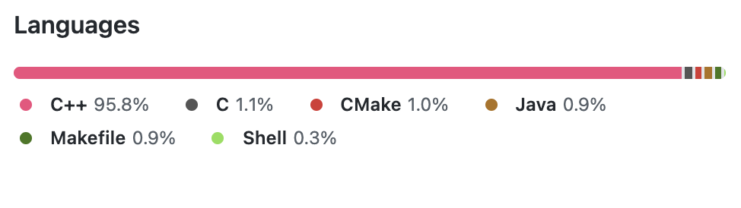

[a] Tesseract

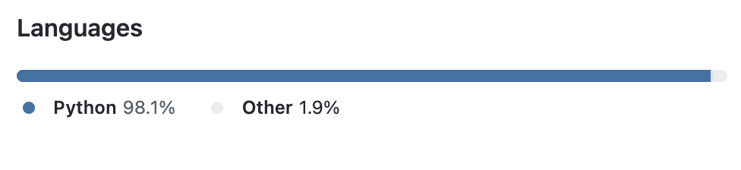

### 

[b] EasyOCR

Figure 1: Percentage of programming languages used for Tesseract and EasyOCR. Figure taken from [30] and [31].

### 1.4.4 Unstructured Support

Understanding the installation of OCR systems, which have inadequate documentation support, is one of the most difficult and time-consuming tasks. This is primarily due to the tools' evolution over time from a less accurate fundamental structure to a more complicated and effective tool. Multiple pieces of research have been conducted to support the creation of newer tools for these complex systems.

### 1.4.5 Font Styles

There are various font styles in which the scripts can be found. These fonts can have variations in between the characters, which makes it difficult to perform the segmentation task [37]. Moreover, the characters of different fonts also have patterns which makes it furthermore difficult to recognise characters. Some commonly used font styles in writings are shown in Figure 2.

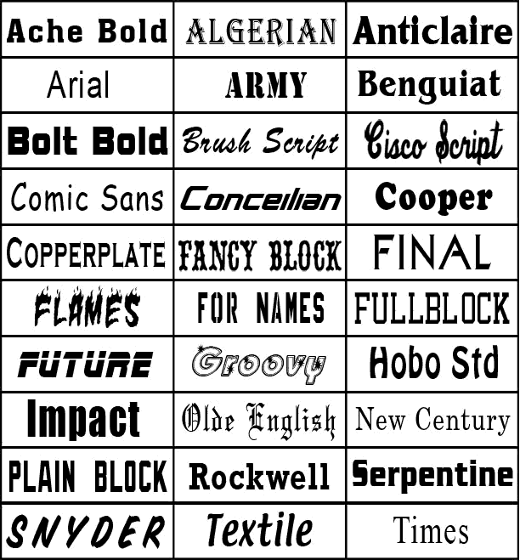

Figure 2: Example of some common font styles and their structure

### 1.4.6 Uneven Surrounding

The pictures can be taken in different environments and so the quality of the image might change depending on the surroundings. Due to these uneven surrounding conditions, the picture might be angled, skewed, or tilted. This leads to degradation of the required characteristics of the image which in turn impacts the output of the OCR tool [37]. This challenge is majorly encountered in the images captured using a camera and not in the case of the scanned images.

### 1.4.7 Language Barrier

Languages also play an important role in the performance of the tool and possess heavy challenges for computation. Simple English text can easily be converted but when it comes to tougher languages like Chinese, Arabic, etc. OCR systems tend to fail due to the style of writing and difficulty to divide the sentences into words and characters. Typographic errors also make the conversion challenge. These errors can be due to the italics style writing, background colour error, errors due to the size of the font, etc. All these aspects make performing OCR challenging and difficult. And due to these challenges, the accuracy of OCR tools is not 100% and requires human intervention to complete any task.

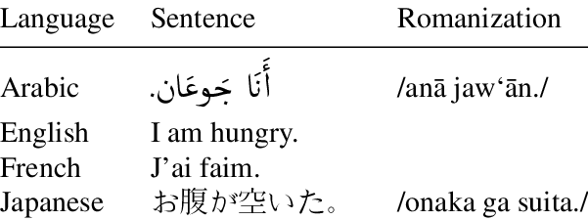

Table 1: Sentence structure in different languages

## 

## 1.5 Why Tesseract and EasyOCR

Out of n-number of available OCR tools in the market, this research specifically focuses on the Tesseract and EasyOCR. This selection is made by taking into consideration a few parameters such as the diversity of the community involved in usage and development of these tools, the common architectural elements and their future scope of research.

### 

### 1.5.1 Community

The open-source community of all the three mentioned tools is large and active. Taking into account the large fan base, these have a very diverse community from across the globe. The size of the community can be easily measured by looking at one of the most common version control software, Github. A star rating of 41.6k with over 45 releases in the last 13 years makes Tesseract one of the most popular OCR tools [30]. EasyOCR comes on second with 12.4k stars [31] and is not as popular as Tesseract because it is a newly developed tool but has shown exponential growth with 14 releases in just 2 years.

### 1.5.2 Diverse Comparison

Tesseract is considered to be a very old tool with a long history of heavy evolution in multiple stages whereas EasyOCR is quite new and does not have many evolving elements. This makes the comparative research more deeply and gives a chance to understand the changes made in the architecture with the specific reasons and results of those changes. Also, it helps in finding the difference in the performance of an older tool with a modern tool.

### 1.5.3 Common Architectural elements

Both these tools use specialised recurrent neural network – LSTM as their base extractor, making them very advance and technologically complex. This architectural element not only gives a better accuracy but also gives them a wide-angle for the integration of different models to support their future growth.

### 1.5.4 High Future Scope

These tools hold a good amount of work that can be carried out in future to make them more accurate and reliable. This gives a scope for this research to be carried forward and create a reference for future researches/work being done on the these tools.

## 1.6 Motivations

There are numerous elements that contribute to the motivation to pursue this particular research topic. These factors include the quality of available OCR software, the variety of documents, and the commercial challenges involved.

### 1.6.1 Quality of tools

With the advancement in technology and a wide research in the computer vision and neural networks, OCR tools available in the market have gained a lot of popularity. Due to diverse usage and increased demand, there has been a significant rise in the number of tools available. This has resulted in creation of various tools with low accuracy and improper quality of analysis.

### 1.6.2 Variety of documents / Writings

For centuries, writings have been considered to be a consequence of cultural diffusion originating from the Mesopotamian civilisation from the early Bronze era. After multiple discoveries from various regions of the world, it has been confirmed that the origin of writing is not from one region or century rather there were multiple origins. These writings had varied structures and forms, which ultimately gives solid evidence of having multiple independent origins. With the continuous evolution from writing on stones to writing on paper and in recent times, with the advancement in technology, going paperless has become a new mantra. This lead to the creation of billions of document types with varied writing styles. Converting a good amount of text from various image types having different structures and language styles is a challenging task.

### 1.6.3 Commercial Challenges

In various workplaces, a vast amount of time is spent on unwanted tasks such as sifting through stacks of documents, performing manual entries, organising bills, matching documents, etc. Due to these unproductive tasks, the demand for OCR technology is increasing in every domain of the industry. With the technological evolution and increased demand, there are various OCR tools available in the market and it becomes difficult to choose the best one according to the structure, quality, and quantity of the document.

### 1.6.4 Strong Future Needs

The growth and need of optical character recognition in every sector of the industry have been mesmerising, but it is important to understand that OCR is not just required for the conversion of analog text to digital format whereas it has usage far beyond. It can be further used to generate insights and useful results there is still a need for a lot of research in this domain.

### 1.6.5 Existing Work

Even after having many use cases, there are very few optical character recognition tools available to convert images into text in the market for free. The available OCR tools have their own set of steps to implement them on different images dataset. Due to these differences, the metrics used for evaluating the performance of these tools is dependent on multiple factors and vary according to the implementation and the results of the tool.

In terms of existing comparisons and predictions, Vijayarani [11] lists a few of the common OCR tools available online for free, to compare their performance on the basis of accuracy and word error rate. She talks about text types and their performance issues while applying the conversion task. Her result specified that the OCR tools were not able to detect and convert the symbols and different kinds of font involved into text. The outputs in that space were usually blank.

Shivani [12] talks about the two open-source OCR tools and compares them on the basis of two different parameters accuracy and precision. She told about the difficulty of comparing OCR performances for the handwritten images and takes into consideration only the printed documents. Their results specified that the Tesseract outperforms Google OCR for most of the documents but lags in some cases.

Marcin [13] compares the OCR tools amongst the highest market shareholders. They highlight the importance of training the models to increase the performance of both tools. Their comparison results marked the competitiveness in the OCR tools available.

## 1.7 Thesis Overview

Optical Character Recognition or OCR is a technological conversion of images of texts, either machine written or handwritten, or scanned copies into an editable or machine-readable format for further processing. OCR has gained a lot of popularity in the last few decades and there are various tools available like Adobe, Abbyy and Rossum (just to name a few). A few open-source tools like Tesseract, Vision, OCRopus, EasyOCR have a tremendous count of forks on GitHub, and they lay a foundation of many other tools and frameworks available in the market. The accuracy of the image to text conversion is dependent on multiple factors like the quality of the image, tools used to carry out the process, pre-processing steps used, text category, etc. There are various constraints related to the conversion of images to digitised text as images tend to have multiple complexities, making it inefficient for machines to understand the text embedded into the image. A major chunk of OCR systems is used on character isolation. All the characters of a sentence are read individually to make it easier for the machines to understand and process the document. However, a low-resolution image makes it difficult to understand the text, which can further lead to problems like character mixing. Moreover, it is difficult to find the difference between the digits like 6 and 8 or 1 and 7, due to their writing structure. The background colour on which the text is printed also plays an important part in text recognition. Due to a lot of research, there are a variety of OCR tools available in the market with high accuracy. If the OCR tools have very high accuracy, do they differ in any way? Do different architectures give the same accuracy? Does the input image change the output for different OCR tools? This thesis goes a level up to the other previous research. Here we compare the outputs of the two most famous Optical Character Recognition engines: Tesseract and EasyOCR.

We start this thesis by introducing OCR and then moving towards the more technical side of the research. A thorough background is covered with the introduction of all the technical terms, conceptual terms, history of both the OCR tools, architecture of both the OCR tools, a comparison of both the tools and the resulting experiment. We use different graphical outputs and diagrams throughout the thesis to explain the concepts and results of the tools. The experiment is performed using the Python programming language due to its vast collection of libraries and API support for using the OCR tools. And the integrated development environment used is the Jupyter notebook because it gives all the necessary formatting to compare and interpret the results either graphically or numerically.

The dataset that is used to carry out the experiment consists of a collection of images from different categories of media sources with varying dimensions and the quality of text captured. The images are broadly classified in three categories, namely, invoice images, article images and advertisement images. This categorisation is done by considering the structure of the image, number of pictures in the image and the commercial usage. Moreover, the text written in the images is not limited to a single language, that is, a multilingual dataset having English, French and Catalan languages, is used for this comparison.

Agile methodology is used as the working method for model creation and comparison throughout the project. This methodology led to continuous iteration of the model, making it an efficient model for this comparison.

The thesis concludes by stating the results of the comparative study of the tools. It gives an insight into the category of tool that should be used by initially analysing the condition of the input image. It also helps to understand the commercial usage of tools according to the size of the input document. Moreover, a detailed understanding of the architecture and the steps involved in the optical character recognition of both tools is gained by the end of the project. This project also lays the foundation for using the other OCR tools in the market as it compares the two most popular tools having complex architectures.

Structurally, this thesis comprises of 5 chapters. These chapters are arranged in an easy-to-understand order. The first chapter gives the introduction of the whole thesis starting from the basic definition of OCR to its use-cases. The second chapter covers all the technical concepts which are essential to perform the experiment successfully. These concepts start from the basic architecture of the tools being used to their practical working. The third chapter carries all the execution part. In this, all the essential coding for both tools are done to implement the research. This section discusses the hurdles that arise in the execution and how those hurdles were solved to implement the OCR. The fourth chapter outlines the comparison of the outcomes of both tools. It categorises the tools according to their performance and accuracy. The last chapter lists the outcome of the experiment, with results and gives a summary of the project. Due to continuous evolution in the OCR technologies and their increased usage, this thesis also includes the scope of the future works that can be carried out using this research as a reference. Moreover, it also states how this research can also be extended to compare other commonly available and famous open-sourced OCR tools with comparable fan base and availability in the market. Close to the end, a reference list of all the resources used to carry out this research is attached, to give a better understanding and reliability to this project. Finally, all the input images are attached at the end of this thesis under the Appendix A section.

- the data size is small and therefore this needs addressing (you dosay that this is due to computational cost,

   but a reader would want to know why you could not do - say - 10 times more pages, how many hours would that have been, etc?)

   that also would have implications for the statistical significance of the comparisons, so you should say

   in the critical discussion that those conclusions are referred to the specific selection of data that you used

   -- but that this was in turn chosen by hand to be representative...  --

-  is the word Exhaustive the best word to describe this study? (given small data sizes, and jjust 2 algorithms) - maybe a systematic comparison (though still 'small scale')... ? look around for possible alternatives... // set the right expectations in the Reader //

- make sure that you cite every paper and tool that you used, PARTICULARLY when you introduce the PERFORMANCE MEASURES

   that are normally standard things that one takes from textbooks....

-- citations, quotes, references... make sure you do not give the wrong impression to our software that checks submissions ... - better to cite / add references / more than less...

-- there are some blank sections, eg in 2.7

- i would not use the expression "failed" for an algorithm, in this context, of "both tools failed" ... perhaps "neither came out as the clearly preferred option " ?

-- btw: if you decide that there is "no clear winner" should this not be part of the abstract, as is the output of your study?

-- if your study is Multilingual, should nthis not be showcased in the Intro / absract? (along with a shocase of diversity in the data:

"while being small, out dataset is diverse, with a combination of english and french, and receipts and articles" == whatever, i forgpopt the details

but you get the point here...

-- cite sources for CER and WER definitions

--3.3 the word exhaustively used out of domain? maybe you meant "widely used"?

-- 3.4 dataset - here you need to address the problem with SIZE, and emphasize your philosophy to have a very diverse set of images

    including language, type, date of the documents...

-- if you have 12 images only, what stopped you from having 120? just explain, if your laptop+lockdown prevented you

  from doing a bigger study, just say so,... ?

-- you should say that your conclusions about which type of input has which type of performancve

    are referred to THIS SAMPLE, since there is not enough statistical power to draw general; conclusions from a small set of images...

-- ch4 - critical evaluation - here is where you say that your pipeline is general and powerful, the methods used are also general and exportable,

but in this specific cse you were constrainedby computational resources and therefpore you had to limit your study to a small sample

however your report results that are descriptive of this sample, and that this samplewas chosen to be representative, etc etc

(in other words: WHAT CAN WE MAKE OF THOSE TABLES IN CH 3 ?)

-- 4.2.1 and 4.2.2 -- simplify and clarify wording:

    "Skewness of input image affects performance in Tessseract... " instead of what you have .... etc etc

-- standarsise format in references (eg [29] )

**Chapter 2**

# Technical Background

The principles connected to the OCR tools that are compared are introduced in this chapter of the thesis. It begins with a glossary of terms and a brief overview of neural networks, which serve as the foundation for OCR systems. Then it continues to a Recurrent Neural Networks, a type of neural network that forms the base of both the tools. It then goes on to present a brief history of both tools, as well as an architectural overview and explanation of how they work. Finally, the notions of error rates and the technologies that were employed are explained.

## 2.1 Terminology

**Pixel.** A pixel is the building block of an image. These pixels are responsible for given different colours to the image as they are made of variable intensities. A resolution of 1920 * 1080 pixels resembles that there are 1920 pixels in every row of the image and 1080 pixels in every column of the image. The more the pixel density, the better is the image quality.

**Binary image.** A binary image also called a two-segment or bi-segment image is an image that consists of only two colours, black or white. This means that the image consists of only two types of bits: 0 or 1, hence the pixels will be stored as either 0 or 1. It is a very common term in image processing and

**Grayscale image.** A grayscale image, also known as a grey monochrome image, is made up of only shades of grey. It is different from black and white images as it consists of all the shades of grey and not just black and white colours.

**Digitized image.** It is an image that is converted into a format that can be used as an input to the machines.

## 2.2 Neural Networks

The human brain is the most complicated part of the body. Numerous studies are being conducted to better comprehend its structure and operation. It attracts a lot of research and study due to its extensive abilities and small size. In 1943, McCulloch and Pitts [1] pioneered the use of neural networks in artificial intelligence to imitate the activities of a human brain using a variety of methods. The roots were laid to solve computational problems in a way similar to the human brain. Later, with the advancement of technological hardware and reduction in cost, these were used to perform a variety of tasks. They carry a lot of importance to solve day to day problems with multiple types of complexities. These networks, which are made up of neurons that resemble biological neurons in brain cells, are utilized to carry out complex tasks. Artificial neural networks, convolutional neural networks, and recurrent neural networks are the three main forms of neural networks.

### 2.2.1 Artificial Neural Network

Artificial Neural Networks, also known as Feedforward Neural Networks (shown in Figure 3), are the most basic type of neural network, consisting of a group of neurons that all work in the same way. The Perceptron was designed by psychologist Frank Rosenblatt in 1958 to correlate it with the human brain [2]. It doesn't work well with image data because it only accepts one-dimensional input, which implies the images must be transformed to one dimension. This conversion not only increases the input's parameters but also removes the image's features. As a result, ANN does not work well with image data.

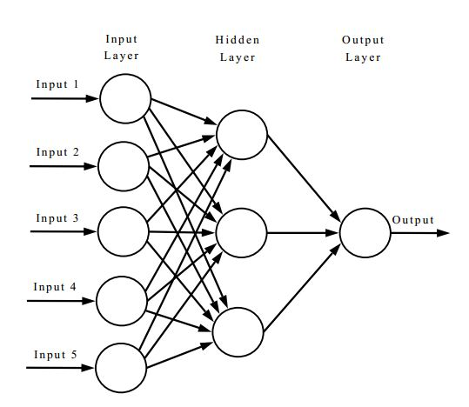

Figure 3: Artificial Neural Network

### 2.2.2 Convolutional Neural Network

For visual tasks, Convolutional Neural Networks are commonly utilized. Different models were proposed to recognize patterns in the same way as the human brain does, however they all had distortion and placement concerns. Frank Rosenblatt introduced a three-layered perceptron in 1962 [4], while M. Kabrisky presented a visual information processing model in 1966 [5]. Kunihiko Fukushima, a Japanese computer scientist, coined the term "neocognitron" to describe these neural networks' ability to self-organize and recognize patterns in 1980. The building blocks of CNNs are known as kernels. It quickly extracts the data from an image and determines the relationship between the individual pixels of that image. This aids in the division and identification of various aspects of the image. The main disadvantage of this network is that as the number of hidden layers grows, it becomes slower. Furthermore, if the dataset has a variety of features, it is quite difficult to construct the network.

There are various traditional architectures for CNNs that have similar general principle of stacked layers of networks whereas the newer architectures try to find a more reliable and faster network layer to build CNN. Almost all of these networks follow the same design principles for the input. The famous LeNet5, introduced to recognise the handwritten digits by Yann Lecun et el in 1998 [6] is the historical CNN architecture which is trained on 60000 images dataset.

The AlexNet architecture is based on the LeNet-5 architecture and was developed in 2012 by Alex Krizhevsky et al. to compete in the ImageNet competition [28]. The architecture of AlexNet was designed to understand much complex objects and hierarchies. Due to this complicated structure, the time required to train the model was increased a lot. To reduce the training time, it was trained on GPU as the number of cores in the GPU are much larger than a CPU. This architecture resulted in better image recognition, ultimately giving better OCR outputs.

### 2.2.3 Recurrent Neural Network

Artificial neural networks are used to construct recurrent neural networks. J. Hopfield first proposed a special type of RNN, the Associative Neural Network in 1982 [7] to improve the predictions of neural networks. To do so, these networks can store the sequence of inputs in their associated memory. Since RNNs take input from the preceding layer, they are computationally less expensive, allowing them to make predictions with less data. Long sequential data might be challenging to train and process in a recurrent neural network.

All the three categories of neural networks are used for different purposes since they all have varying structures.

## 2.3 Long Short Term Memory

Hochreiter and Schmidhuber introduced a common type of gradient-based Recurrent Neural Network known as Long Short Term Memory or LSTM in the late 1990s to overcome the challenge of information storage across long time intervals by altering the gradient [8]. It's a considerably more advanced neural network than a feedforward neural network. The major purpose of LSTM was to improve the accuracy of RNN models while also addressing the issue of long-term dependency.

Every LSTM unit has a memory cell that can store data for a fixed amount of time. The input gate, output gate, and forgotten gate are the three gates that handle information retrieval, storage, and deletion in the LSTM architecture. The input gate determines how much data from the preceding layer will be stored. The output gate determines how much data should be delivered to the following layer. The forgotten gate, on the other hand, decides when the data should be deleted. LSTM devices come in a variety of shapes and sizes, each with its own set of advantages and disadvantages.

Gers & Schmidhuber introduced a notable LSTM version in 2000, in which gate layers can evaluate the state of the cell [33]. Another variation was introduced by connecting input and forgetting gates, where the judgments are made collaboratively rather than separately deciding what to leave out and what to add. Cho, et al. introduced the Gated Recurrent Unit, a model that is easier to grasp than a traditional LSTM model, in 2014 [34].

## 2.4 Image Processing

In simple terms, image processing can be defined as the process of enhancing the image for various kinds of information extraction. There are mainly two methods used for image processing, namely, analog image processing and digital image processing. The analog image processing method processes hard copies or physical images. Whereas, the digital image processing method processes digital images, that is, images stored on computers or other electronic devices with the help of various computational algorithms. There are a number of open-source image processing libraries available on the market, the most popular of which is OpenCV, which contains a number of libraries that are required for image processing tasks.

## 

## 2.5 History of OCR tools

### 2.5.1 Tesseract

One of the most widely used optical character recognition techniques is the Tesseract OCR. It was the subject of a research effort at Hewlett Packard Labs in Bristol that began in 1984 and lasted until 1994 [31]. Some critical changes were made to the port's windows in 1996. Hewlett Packard opened sourced Tesseract in 2005, and Google has been the primary sponsor for Tesseract development and testing since 2006. Tesseract 4 was published in 2018, with a significant improvement to the LSTM-based recognition engine integration.

### 2.5.2 EasyOCR

EasyOCR is a modern character recognition library released in July 2016 [30]. It is created in the name of a private organisation, which specialises in AI, registered as JaidedAI by using multiple research papers and open source code repositories with an aim to build a better performing character recognition tool. It is regarded as one of the most user friendly character recognition tool amongst available high accuracy tools. With the latest version released in 2021, this library supports 80+ languages which includes the most difficult writing scripts such as Chinese, Devanagari, Latin etc. The library is most suitable for Python users as it is written in Python with complete deep learning segment in Pytorch.

## 2.6 Architecture and working of OCR tools

### 2.6.1 Tesseract

C. Patel et al. introduced the architecture and working of the Tesseract as a combination of 5 different segments [32]. The first segment consists of Adaptive Thresholding, wherein the image is converted into its binary version. In the second segment, known as page layout analysis, the character outlines forming the individual blocks are extracted from the converted page. The outlines of the text are identified and turned to blobs in the third segment, which is also known as the line recogniser section. These are further divided into words by understanding the area or text size. The last two segments are used for the word recognition task. The first segment performs word recognition using a simple classifier. The words which cross a threshold level are recognised and saved as a training dataset for the classifier. Using this dataset, the second segment looks for the remaining words which were not recognised in the previous segment. The complete architecture is shown in Figure 4.

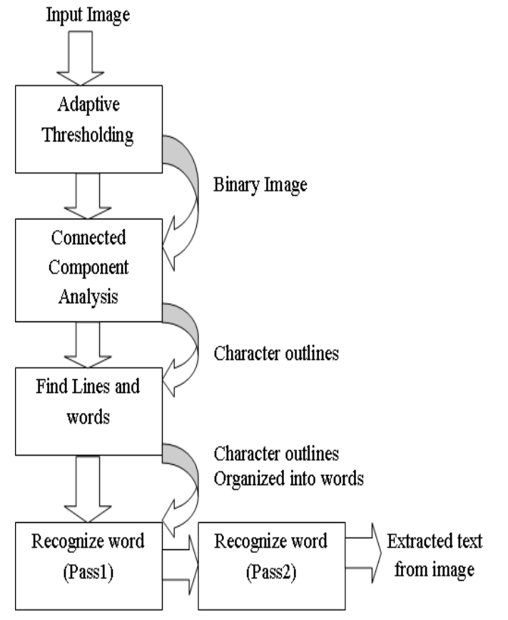

Figure 4: Architecture of Tesseract OCR. Flow chart taken from [32].

### 2.6.2 EasyOCR

The architecture of EasyOCR consists of two different segments taken from several research papers. The first segment known as the Detection part is based on Character Region Awareness for Text Detection or CRAFT framework. This framework was introduced by Baek et al. in 2019 with an aim to overcome the problem of character level annotation [9]. It is designed by using batch normalisation over the VGG16 architecture which is a convolution neural network. It gives two separate outcomes as the region score and the affinity score. The region score determines individual character level localisation while the affinity score is used to create a single instance by using each character. Figure 5 illustrates the schematic overview of the CRAFT framework with output scores.

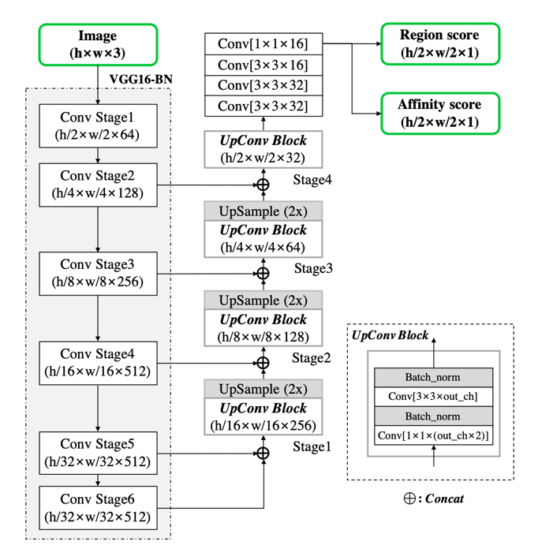

Figure 5: Schematic representation of CRAFT Architecture. Figure taken from [9].

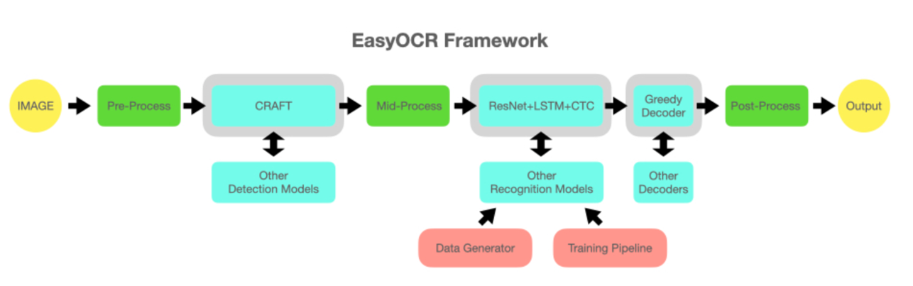The second segment known as the recognition model is based on Convolutional Recurrent Neural Network. This model was proposed by Shi et al. in 2017 to solve the problem of scene text recognition, which is amongst the most important image based sequence recognition [10]. This segment is a combination of three different modules, namely, feature extraction module, sequence labelling module and decoding module. The feature extraction module uses the resnet architecture so as to make it easier to train the deeper networks. This architecture was introduced by He et al. in 2015 by assembling the residual functions with reference to the input layer by removing the unreferenced residual functions from learning [15]. The sequence labelling module is based on the LSTM. And the last, decoding module, uses the novel method of training the recurrent neural networks which works on the existing neural network classifier and its principles [14]. The complete framework of EasyOCR is illustrated in Figure 6.

Figure 6: EasyOCR Framework illustrating both the segments of processing. The figure is taken from [30]

## 2.7 Character Error Rate

Character Error Rate [38] is a heavily used performance metrics to calculate the error rate in machine translation systems majorly OCR. Equation 2.1 (taken from [38]) shows the formula by which Character Error Rate can be calculated.

|  |  |
| --- | --- |
| $$Character Error Rate = \frac{S_{c} + D_{c} + I_{c}}{N_{c}} = \frac{S_{c} + D_{c} + I_{c}}{S_{c} + D_{c} + C_{c}}$$ | (2.1) |

where:

|  |  |  |
| --- | --- | --- |
| Variable | Meaning | Example |
| Sc | Number of substituted characters in the output. | ‘123490’ gets extracted as ‘1Z349O’, which means, ‘2’ and ‘0’ gets substituted as ‘Z’ and ‘O’. |
| Dc | Number of deleted characters in the output. | String ‘ABC1234’ gets extracted as ‘AC123’. Here ‘C’ and ‘4’ are deleted and not present in the output. |
| Ic | Number of inserted characters in the output. | A series of characters ‘94127’ gets converted into ‘g41Z’ at the output . Here, one character is missing which needs to be inserted to compare with the ground truth. |
| Nc | Total number of characters in the ground truth excluding the inserted characters as initially they were not available. | String ‘ABC1234’ is the ground truth and has 7 characters. |
| Cc | Number of correctly extracted characters in the output. | Sum of all the correctly extracted characters. |

The percentage of characters in the ground truth that were predicted inaccurately in the OCR output text is the result of this equation. The performance of the OCR is justified by the value of the CER as, lower the value of CER, better is the performance of the tool.

It is common to see a CER value crossing the 100% mark when the reference text size is large but the mistakes in the output are larger, or majorly when the number of time the insertion operation performed is high. To bring the value of CER in the range of 0-100%, a normalisation technique is used. The number of mistakes can be divided by the summation of the number of number of correct characters and the number of edit operations.

The normalised equation of Equation 2.1 can be stated as:

|  |  |
| --- | --- |
| $$Normalised Character Error Rate = \frac{S_{c} + D_{c} + I_{c}}{S_{c} + D_{c} + I_{c}+ C_{c}}$$ | (2.2) |

Another important consideration made while calculating the CER are the blanks or white spaces as they play a crucial role in separating the words and making a meaningful sentence. Example, mangoes and man goes have a completely different meaning. Generally multiple white spaces are considered as one during the calculation.

There are various theories that define different ranges of CER value for a good OCR output. These values vary according to the structure of the document, quality, type of content, writing style of the text etc. A common reference taken to resolve this conflict and to set a benchmark for the newspaper style dataset is taken from an article from the Australian Newspaper Digitization Program, 2008 [16]. These benchmarks were:

* Poor OCR accuracy: The character error rate > 10%
* Average OCR accuracy: 2% < character error rate < 10%
* Good OCR accuracy: 1% < character error rate < 2%

These benchmarks are not valid for hand written text as it is very difficult to get consistency and the content can be a combination of symbols and out to vocabulary words. A character error rate of 20% can be considered as a satisfactory level for hand written data set.

## 2.8 Word Error Rate

Word Error Rate is another most widely used performance metrics to measure the machine translation systems. A common problem in calculating the performance of the OCR systems is that the recognised word can have different word size when compared with the ground truth. Calculations involved in WER are based on the Levenshtein distance. This approach cannot be directly implemented because of one of the important drawback that it does not provide with in-depth conversion errors which makes it difficult to understand the required changes to get higher accuracy of the OCR tool. A better approach to use WER as the performance metrics is to align the words that are recognised in the order similar to the ground truth and then perform the calculations. Character Error Rate and Word Error Rate are calculated using the same formula with the difference that the WER is applied on words and CER get in more granular and is applied on the character level. Word level is generally used with the data that has meaning, like paragraphs in a newspaper.

Word Error Rate can be calculated as:

|  |  |
| --- | --- |
| $$Word Error Rate = \frac{S_{w} + D_{w} + I_{w}}{N_{w}} = \frac{S_{w} + D_{w} + I_{w}}{S_{w} + D_{w} + C_{w}}$$ | (2.3) |

Where:

|  |  |  |
| --- | --- | --- |
| Variable | Meaning | Example |
| Sw | Number of substituted words in the output. | ‘Vitamin’ gets extracted as ‘Vltamin’, which means, ‘i’ gets substituted as ‘l’. |
| Dw | Number of deleted words in the output. | In sentence ‘World needs to control pollution’, ‘needs’ does not get extracted due to inefficient tool. |
| Iw | Number of inserted words in the output. | The word ‘Mangoes’ gets converted into ‘Man goes’ at the output. Here, the meaning of the word gets completely changed when compared with the ground truth. |
| Nw | Total number of words in the ground truth excluding the inserted words as initially they were not available. | ‘Have a good day’ is the ground truth and it contains 4 words. |
| Cw | Number of correctly extracted words in the output. | Sum of all the correctly extracted words. |

However, one disadvantage of adopting a general formula (as stated in Equation 2.3) is that it ignores the impact that different sorts of faults may have on the likelihood of a successful conclusion, for example few errors can be heavier than others and few can be easy to remove. Moreover, it becomes difficult to segregate the errors by sum of deletion and insertion error from the substitution error. Thus, it is advised to derive a formula according to the problem to get the best accuracy calculations. For example, A new formula (shown in Equation 2.4) to calculate the word error rate was introduced by assigning different weights to the errors.

|  |  |
| --- | --- |
| $$Weighted Word Error Rate = \frac{S_{w} + {0.5 D}_{w} + {0.5 I}_{w}}{N_{w}}$$ | (2.4) |

## 2.9 Levenshtein distance

Levenshtein distance is a string metric that is used to compare two string sequences. In other words it is the smallest number of required edits done on individual characters (insertions, deletions, or substitutions) to transform one word into the other. This distance is named after a Russian scientist and mathematician Vladimir Levenshtein, who used this distance metric in 1965 [17]. The distance computed between the two strings a, b having a length |a| and |b| can be given as:

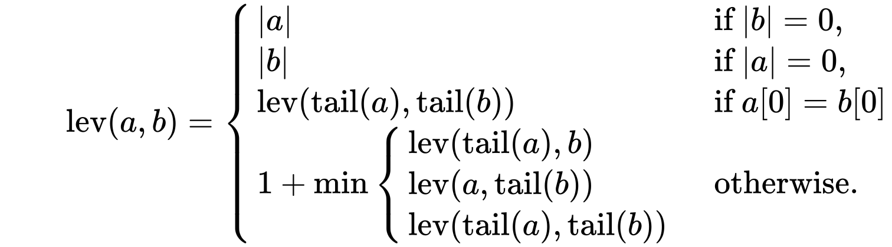

where the tail of some string x is a string of all but the first character of x, and x[n] is the nth character of the string x, starting with character 0.

There are various upper and lower bounds for the Levenshtein distance which can be described as:

* For the two strings, it is at least the size difference between them.
* The highest distance should not be greater than the length of the longer string.
* If the length of the strings are equal, the distance is zero.
* The Levenshtein distance follows the triangle inequality law, that is, the sum of distance between the two strings should not be greater than the sum of Levenshtein distance from the third string.

## 2.10 Confidence Value

The error rates calculated help in predicting the confidence value for any OCR to evaluate its performance. These values are further used in industries to define a threshold value and to get an understanding of certain processes that can be automated end-to-end and those which require human interaction wherever needed throughout the process.

This can be easily understood by taking into consideration certain scenarios. For example, a pharmaceutical company involved in analysing the drug information from the label might need to introduce a lower threshold value so that it can introduce human interaction in the process for the granular verification of the data for the labels that qualify that threshold value. It is important to do this because incorrect information extraction from the drugs label can cost a lot of lives.

A second scenario can be considered where a loan application company needs OCR for the document processing task. It can set a medium confidence value threshold as human interaction will only be required to have an overall glance at the application.

## 2.11 Technologies

There are various technologies used for the implementation of this project. It is majorly due to wide usage of latest technological support required for the execution of the OCR algorithms.

### 2.11.1 Jupyter Notebook

It is a free, open source integrated development environment used to create coding files which can be easily shared with other users through platforms like GitHub, Dropbox etc. It There are many IDEs since decades for computational tasks but Jupyter Notebook is one of the most popular one because of its ability to supports more than 40 coding languages which makes it a good choice for a wide community of developers.

This is the best IDE for the OCR projects because it can be easily integrated with big data technologies like Hadoop and Spark by simply using the common programming language, Python.

Moreover, Jupyter Notebook provides beautiful and interactive visualisations essential for any Data Science project. The best part of using this IDE is that a user can write a line of code and see what happens by that code immediately in the next line. This provides an interactive approach towards data visualization and gaining insights. It also helps in debugging and modifying the code easily as the execution process takes place line by line.

According to Dr. Jeffrey M. Perkel, there were more than 2.5 million jupyter notebooks available on the code sharing platform GitHub in 2018 [22].

### 2.11.2 Matplotlib

It is an open source Python library used for creating data visualisations and plotting graphs. It is a cross platform library built over NumPy and is an alternative to MATLAB. It is written in such a way that a few lines of code can easily create great plots. It was written by J. Hunter with many other contributors marking an initial release in 2003 [23]. It gradually become the most widely used visualization tool amongst scientist worldwide. It provides APIs to connect with other third party tools which can be further used for interactive developments. There are various plots supported by matplotlib, some of the common ones are:

* Line Plot: Simple Line plots illustrated in Figure 7a can be created by using the *plot( )* function provided by the matplotlib library.
* Sub-plot: One of the easy-to-compare feature that matplotlib supports is the creation of multiple subplots by using the *subplot( )* function. This feature helps in comparing multiple plots in a single cell as shown in Figure 7b.
* Images: It is important to analyse images dataset for this project. Matplotlib provides easy display of images by using the *imshow( )* function. A sample image is shown in Figure 7c.
* Histogram: Histogram plays in important role for analysing big datasets. Matplotlib provides with *hist( )* function to create histograms and get bin counts. A histogram plot is shown in Figure 7d.

Figure 7: Some of the most commonly used plots created using open sourced MATPLOTLIB

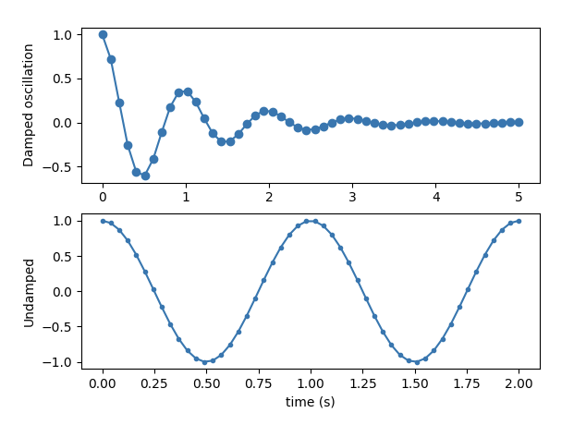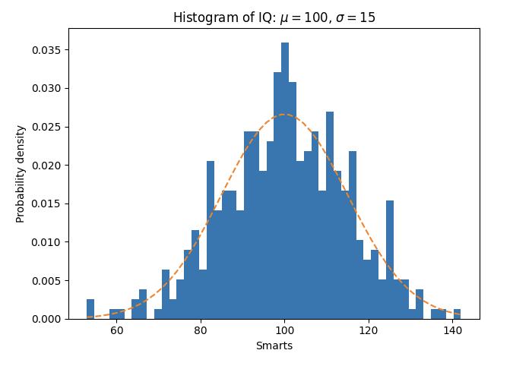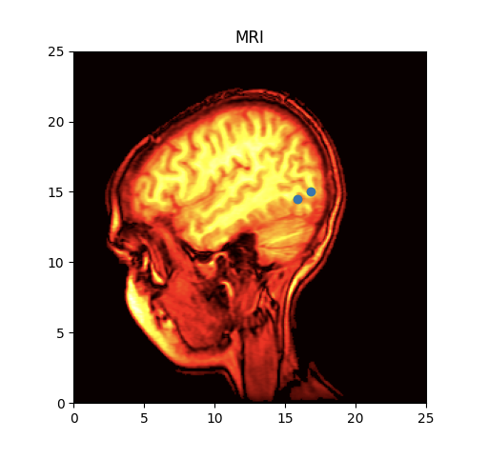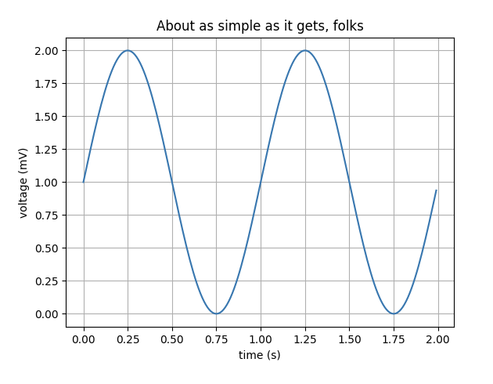

*[c] Image*

*[d] Histogram*

*[a] Line Plot*

*[b] Sub-plot*

### 

### 2.11.3 Pillow

It is the most widely used Python library for image processing tasks. It is important to understand different image types as the image type can heavily influence the OCR output. Some the major file types that are supported by this library are:

* BMP (.bmp): Bitmap Image File format is a raster graphics file format used to store two dimensional images which can be monochrome as well as coloured. This image format is device independent and can easily display images on windows or mac without the use of any external graphics adapter.
* EPS (.esp): Encapsulated PostScript is a file format that was created by Adobe in 1992 essentially for vector images. It gained popularity amongst designers due to its ability to get resized without any loss of details.
* GIF (.gif): Graphics Interchange Format is the most widely used format of images over the social media platforms across the globe due to their support on any kind of device. This format was released in 1987 by an American scientist Steve Wilhite at a service provider company [24]. In gif, it is important to have pixels arranged in proper order, otherwise the file size becomes too large. The colours in a gif are defined by three components red, blue and green. These components are allocated 8 bits resulting in a total of 224 or 16 million colour combinations.The gif limits the colours used in an image to 256 in general. But these 256 colour combinations can be any out of 16 million colours, resulting in a rich diversity of colours.
* JPEG (.jpeg): This file format derives its name from Joint Photographic Experts Group. With the exponential growth in the images data, jpeg has become a very common storage format for digital images due to its characteristic lossy compression. It is also regarded as the standard for image compression since 1992 when it was introduced. The degree of compression can be manipulated by adjusting the compression parameters. A little loss in image quality is seen with the standard compression of 10:1 achieved by jpeg images. According to a survey held in 2015, there are billions of jpeg images produced on a daily basis.
* PNG (.png): Portable Network Graphics is another type of raster graphics file format for images to provide them with a loss less data compression. It was developed by a team of individuals which were later called the PNG group, to replace gif file format due to unnecessary royalties required to be paid by the supporting companies was put forward by the company that patented GIF.
* TIFF (.tiff): Tag Image File Format is one of the most popular file formats used for optical character recognition, image processing and scanning tasks. It is also a raster graphics file format. The main aim behind creating this file format was to reach a common file format for all the scanned documents as there were diverse file formats available.

A detailed comparison between all these formats is shown in table 1 below.

|  |  |  |  |  |  |
| --- | --- | --- | --- | --- | --- |
| Image Format | Compression | Available Colours | Pros | Cons | Uses |
| BMP | Lossless | Variable | Structurally simple and easy to understand. | Compressing the image is difficult and not supportive. |  |
| EPS | Lossless |  | Wide adaptability and cross platform compatibility.  Image quality is very high. | Is it impossible to distinguish between bitmap and vector. |  |
| GIF | Lossless | 256 | Size of image small.  Supports animation and easy compression. | Colour palette is limited in size.  Not suitable for images with vector graphics. | Simple animations, logos, buttons. |
| JPEG | Lossy | 16 million | Image size is small.  Compression is adjustable. | Image deteriorates on compression.  Does not support transparency. | Web Images |
| PNG | Lossless | 16 million | Quality of image does not get affected by compression.  Clean output text files. | Difficult to get graphics pictures.  Larger file size. | Text documents, multilayer image editing. |
| TIFF | Lossless/Lossy | Variable | Photos can be compressed without losing the quality.  Colours specific to device can be handled. |  | Scanned documents, commercial purposes. |

Table 1 – A brief comparison of different image types

### 2.11.4 Open CV

OpenCV or Open Sourced Computer Vision is one of the most common Python library used for solving problems related to computer vision, image processing and machine learning. The project OpenCV was first introduced in 1999 by Intel as a research program to develop CPU intensive applications. After multiple beta versions, the first version was released in 2006. The major contribution on this project came from the experts from Russian headquarters of Intel which majorly comprised of optimization experts and Performance library team. OpenCV library was officially written in C++, making it fast and reliable, but is commonly used with Python.

**Chapter 3**

# Project Execution

The main aim of this project is to compare the performance of different OCR tools on various images. This section of the thesis lays down the methodology used for the end to end execution of the project. It starts with the dataset description and later on moves the focus towards the practical implementation and results of the experiment.

## 3.1 Project Management

Using a version control is essential for any project to safeguard the files and code. *Git* version control has been used throughout the project to keep a track of all the project files and the code. Moreover, since there were multiple different files with same names, it was helpful to maintain them.

## 3.2 Approach

The overall experiment performed in this thesis is divided into three different segments, where each segment comprises of a specific OCR tool. First, the dataset is created by selecting spe

## 3.3 Experimental Setup

The basic aim of this project is to compare the exhaustively available OCR tools. Since the market is flooded with different OCR tools, the experiment is refined for the two most famous OCR tools, that are, Tesseract and EasyOCR. This section walks through the complete environment created to carry this experiment. For every OCR tool, to perform simple and fast image processing, different libraries are installed. These libraries cannot be installed in a single environment due to variations in the versions and support.

**Python Versions:** The environment created to test the *Tesseract OCR* performancecontains the Python version 3.7 and older as the programming language. One of the newly developed tool in this research is EasyOCR. It supports Python version 3 or newer only.

**Matplotlib:** To plot different outputs of both the tools, *matplotlib* library is used in both the environments.

**PyTesseract:** To access *Tesseract* using Python programming language, *pyTesseract* library is installed, which introduces the Python bindings to combine Python and Tesseract.

**OpenCV:** Open computer vision library is installed in all the environments due to its image processing capabilities.

In terms of hardware, since a budget laptop is used to perform all the experiments, GPU was not available so the experiment was setup on a CPU.

## 3.4 Dataset

The dataset used in this thesis is created by combining two different datasets. These datasets are validated from highly prestigious institutions and have been used in multiple competitions as well as for research and development purpose.

The first dataset is based on the pages of a French magazine, *Le Nouvel Observateur*, released during the third week of November 2010. EPITA Research and Development Laboratory (ERDL) holds the copyright of the images used in this thesis ("Copyright (c) 2012. EPITA Research and Development Laboratory (LRDE) with permission from Le Nouvel Observateur"). This dataset was released in February 2013, consisting of 125 full document images with 300 dpi resolution and A4 format with the ground truth. These images consists of pages having articles as well as advertisements. For this experiment, considering 4 unique featured images from both these categories individually, can help in defining every category of comparison required between the OCR tools.

The second dataset is taken from the ICDAR 2019 Robust Reading Challenge on Scanned Receipts OCR and Information Extraction. As proposed by ICDAR, there is no publicly available receipt dataset, hance they created this dataset while taking into consideration the most important factor for an OCR tool, that is, diversity. The scanned images have a varying features like some images have poor paper quality, low resolution and light print; blurred and folded invoice

s. This dataset contains 1000 invoice images having all the above listed features. Out of these images, selecting 4 unique feature images are enough to carry out this experiment. These consists of different image type as well. Invoices are .jpg whereas articles and advertisement are .png. This adds up to the image diversity, making the experiment more broad and reliable.

By using these two datasets, our new dataset consists of 12 images in total, which are later pre-processed making the resultant input images count to 84. This is better explained in section 3.5.

**Moreover, the quantity of images cannot be much higher due to the high cost of machinery required to perform the experiment and the time required for conversion is also high.** Hence, to carry out the experiment successfully, it is important to create a dataset which consists of varying structure of the images, multiple image qualities, diverse textual length, number of objects with multiple placement and most importantly, images that are heavily used in the everyday OCR conversions as this will help in deciding the OCR tool best for a specific category of image.

## 3.5 Input Images

The diverse dataset created using both the datasets contains images with different structures and image formats. These input images are split into three categories, namely, invoice images, articles and advertisement images. This categorisation is done by considering the structure of the images and their commercial use in different industries. All the OCR tools perform internal pre-processing to give the best output result, but still lag in accuracy. To make the comparison more intuitive, every input image is first converted to six different images by following different pre-processing steps. This results in giving 6 pre-processed images and 1 original image as an input to every OCR tool for all the input images taken from the dataset. All the original input images with the pre-processed images are shown in Appendix A.

**Invoice Image 1: normal**

**Invoice image 2: dilated**

## 3.6 Pre-processing Operations

The output of an OCR tool can be less accurate due a variety of reasons, one of them is the poor quality image. Pre-processing of an image is important so as to avoid any kind of accuracy drop due to the quality of the image. Though all the modern OCR tools perform image pre-processing internally, it is important to perform this separately as well because OCR technology still lags a lot in terms of accuracy. As the pre-processing step, the original input image is converted into 6 different images, to understand which category of pre-processed image gives better OCR output according to the input image [25]. This step helps in correcting the visibility, skewness and other portions of the image. The essential image pre-processing operations are:

1. Grayscale conversion: It means converting a coloured image into a grayscale image, that is, an image that does not have any colours but only shades of grey. These shades comprise of a variety of monochromatic shades with white on one end of the scale and black on the other. An example of an image converted from coloured to grayscale is shown in figure 3a.
2. Noise removal: Images can contain random variations of colour and brightness which can be generated by electronic scanners or digital cameras. These random variations build over the original image is known as noise. These variations can be an important portion of accuracy drop of any OCR tool and are sometimes not removed by the internal pre-processing steps of the OCR tools. Invoice image with the reduced noise is shown in figure 3e.
3. Thresholding: It is a process of converting a grayscale image into a binary image, also known as Binarization. It is carried out by replacing those pixels in an image, which have an intensity value lesser than a threshold value, with the dark pixels. And the pixels having intensity greater than the threshold value are replaced by white pixels. This is also known as background and foreground separation of an image. An example of a threshold image is shown in figure 3b.
4. Dilation/Erosion: Character thickness plays an important role in image recognition task. OCR outputs can get heavily fluctuated if a word is extremely thin or thick. To overcome this issue, the process of erosion or dilation is applied on the input image as a part of pre-processing step. In the process of dilation, pixels are added to the boundaries of the objects available in the image (shown in Figure 8). Whereas in the process of erosion, pixels are removed from the boundaries of the object. This process is common on historical data where font size used was usually thicker. Both these processes, dilation and erosion, are complimentary to each other and play an important part in increasing the OCR accuracy.

Mathematically dilation is represented by $⊕$

The dilation of A by B is given as:

|  |  |  |
| --- | --- | --- |
|  | $$A ⊕ B =\bigcup_{b∈B}{A_{b}}$$ | (3.1) |

$$where A_{b} is the translation of A by b$$

Mathematically erosion is represented by $⊖$

The erosion of A by B is given as:

|  |  |  |
| --- | --- | --- |
|  | $$A ⊖ B =\bigcap_{b∈B}{A_{-b}}$$ | (3.2) |

$$where A_{-b} is the translation of A by -b$$

All the morphological operations are based on these two operations, that is, by combining the process of dilation and erosion in different ways, a different processing operations can be created popularly known as compound operations. The most common compound operations are opening, closing and boundary detection.

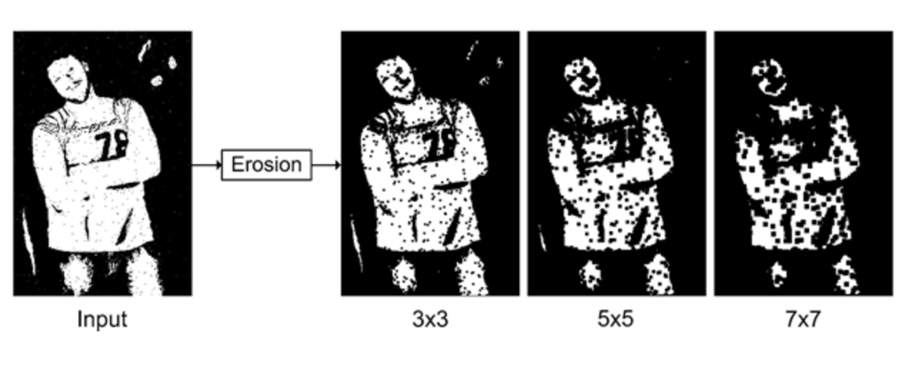

Figure 8: Practical example of Erosion. Illustration taken from [26].

1. Opening: Opening is the process of performing erosion followed by dilation (illustrated in Figure 9). This operation helps in restoring the object size which gets decreased due to erosion operation. It is a beneficial operation when the original object size is important for further tasks.

|  |  |  |
| --- | --- | --- |
|  | $$g\left(x,y\right)=f\left(x,y\right)∘SE$$ | (4.1) |

|  |  |  |
| --- | --- | --- |
|  |  | (4.2) |

|  |  |  |
| --- | --- | --- |
|  |  | (4.3) |

|  |  |  |
| --- | --- | --- |
|  |  |  |
|  |  |  |
|  |  |  |
|  |  |  |

The opening operation is performed on an image, as shown in Figure 9, where it is evitable that after performing erosion there is a decrease in the objects size which is removed by further performing dilation.

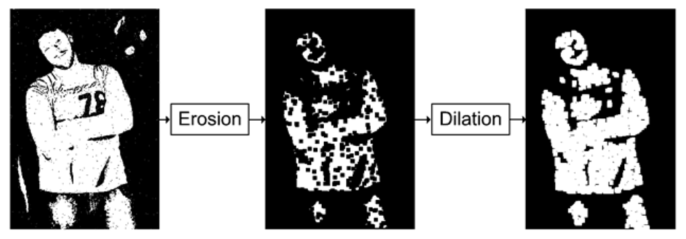

Figure 9: Opening operation performed on a real life image. Illustration taken from [26].

1. Closing: Closing addresses one of the common issues created due to dilation, that is, the increase in object size when it is used to fill in gaps in objects. This problem can be easily resolved by shrinking the object by following the Dilation by an Erosion. This can be mathematically stated as:

|  |  |  |
| --- | --- | --- |
|  | $$g\left(x,y\right)=f\left(x,y\right)•SE$$ | (5.1) |

|  |  |  |
| --- | --- | --- |
|  |  | (5.2) |

|  |  |  |
| --- | --- | --- |
|  |  | (5.3) |

|  |  |  |
| --- | --- | --- |
|  |  |  |
|  |  |  |
|  |  |  |
|  |  |  |

The closing operation is performed on an image, as shown in Figure 10, where it is evitable that after performing dilation there is an increase in the background noise objects which is removed by further performing erosion.

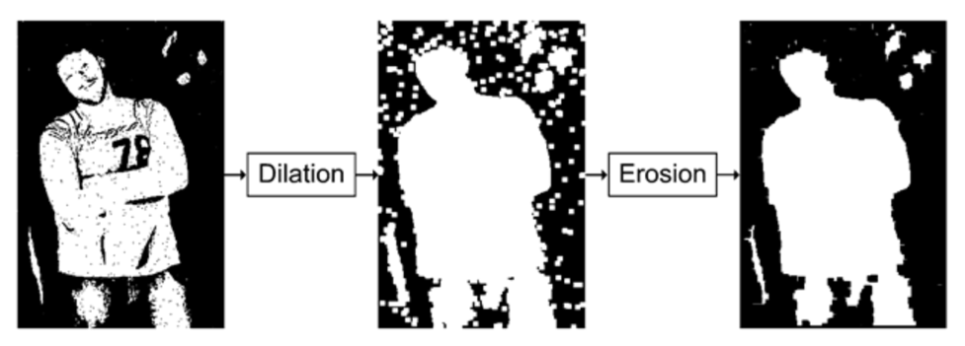

Figure 10: Closing operation performed on a real life image. Figure taken from [26].

1. Edge detection: The boundary in mathematical terms can be defined as the difference between the input image and the eroded version of the image having smaller version of objects. This can be understood by the Equation 6.1 shown below.

|  |  |  |
| --- | --- | --- |
|  | $$g\left(x,y\right)=f\left(x,y\right)-\left(f\left(x, y\right)⊖SE\right)$$ | (6.1) |

Figure 11 gives a practical illustration of edge detection performed on a real life binary image.

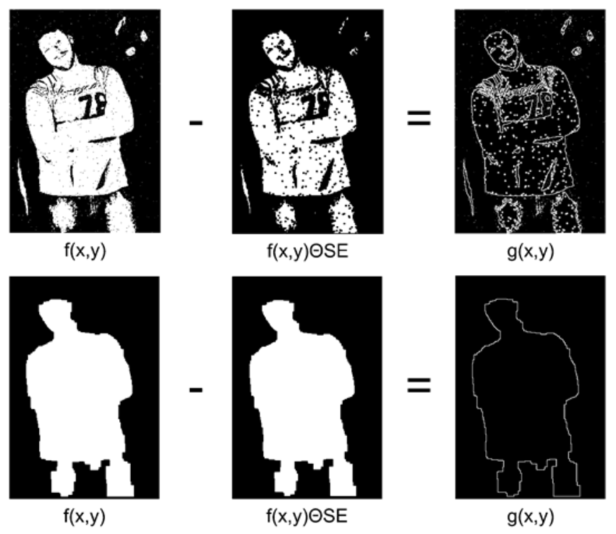

Figure 11: A practical example of Edge Detection.

1. Skew correction: An image can be asymmetric if the page is not scanned properly. Skewness of an image measures the symmetry of the image. If the page is skewed, as shown in Figure 12[a], then the quality of OCR’s line segmentation can be heavily impacted. This can be improved by rotating the page so as to bring the lines at horizontal inclination, as shown in Figure 12[b].

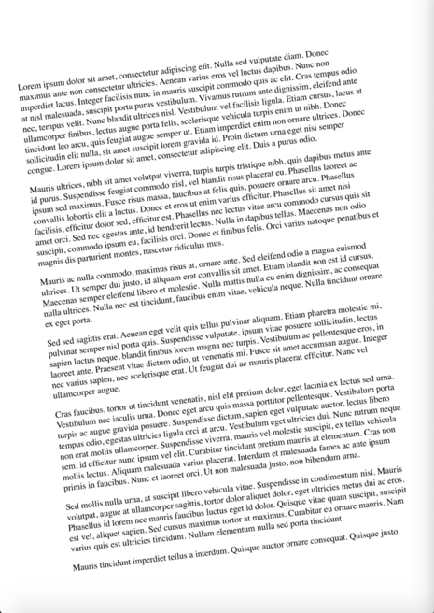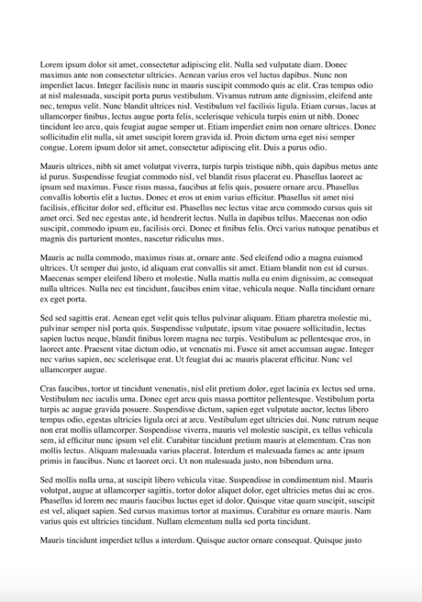

[a] Skewed image

[b] Deskewed image

Figure 12: Skew correction performed on a page of a book. These figures are taken from [27].

## 3.7 Model Architecture

For both the OCR tools, the implementation is divided into five different parts:

* Libraries: As the first step, all the necessary libraries for our task are installed and imported in the OCR environment. The list of these libraries is further updated with the other steps of the implementation, as needed.
* Data Import: This is the basic OCR implementation step, wherein the data/image is imported from the local drive into the Integrated development environment, which in this project is Jupyter Notebook.
* Data Pre-processing: As mentioned in Section 3.6, this step is important to convert the input image into multiple different pre-processed images for better OCR conversion and in-depth comparison of the tools.

* Image to text conversion: At this step, the OCR libraries are given different pre-processed images as input to carry out the process of extracting text from image.
* Error check: At this final step, the output text of all the different input images is compared with the ground truth. This helps in getting the error rates of all the images for comparison.

## 3.8 Comparison Methods

Comparing different OCR tools has always been a very challenging task due to a variety of images available with different image quality, font size, architecture etc. Due to the diversity of the dataset chosen for this task, the comparison needs be done on multiple factors. There are three major comparison methods taken into consideration for this project,

* Character Error Rate: Discussed in Section 2.7.
* Word Error Rate: Discussed in Section 2.8.
* Image to text conversion Time: Due to architectural different and various implementation approaches by the existing OCR tools, time taken to convert an image into text by any OCR tool is a crucial comparison factor.

The WER and CER are evaluated by calculating the Levenshtein distance (discussed in Section 2.9). Wagner-Fisher Algorithm is used to calculate the Levenshtein distance (also known as the edit distance). The pseudo code of the fisher algorithm in shown below. This algorithm helps in determining how different are the two strings. Majorly there are three edit operations used in this algorithm, which are, substitution, deletion and insertion. The algorithm works by assigning different costs to each edit operations but in this experiment, the cost is set to one for each edit operation. This is done to get the maximum edit distance which is equal to the length of the longer string. The edit distance is zero when both the strings are equal.

The output error used for the comparison is:

|  |  |  |
| --- | --- | --- |
|  |  |  |
|  |  |  |
|  |  |  |

|  |
| --- |
| Algorithm 1 - Wagner - Fisher Algorithm (all operations cost equal to one) |
|  |

## 3.9 Results

The results of both the OCR tools are listed in the following tables, which are further explained in Chapter 4.

* Table 1: Lists the output obtained from Tesseract OCR when invoice images are given as input. The outputs are not normalised for better interpretations.
* Table 2: Lists the output obtained from Tesseract OCR when article images are given as input. The outputs are not normalised for better interpretations.
* Table 3: Lists the output obtained from Tesseract OCR when advertisement images are given as input. The outputs are not normalised for better interpretations.
* Table 4: Lists the output obtained from EasyOCR when invoice images are given as input. The outputs are not normalised for better interpretations.
* Table 5: Lists the output obtained from EasyOCR when article images are given as input. The outputs are not normalised for better interpretations.
* Table 6: Lists the output obtained from EasyOCR when advertisement images are given as input. The outputs are not normalised for better interpretations.

These tables list down the individual character error rate and word error rate as well as mean error rate for all the images. To keep the error rates simple to analyse, they have not been normalised, which means the error can go beyond 100% mark. As discussed in section 2.9, it is very common to see the error rate exceeding 100% in OCR projects.

### 3.9.1 Tesseract Output

|  |  |  |  |  |  |  |
| --- | --- | --- | --- | --- | --- | --- |
| Image Category | Image type | Word error rate | Mean WER | Character error rate | Mean CER | Time (in seconds) |
| Invoice_image_1 | Original image | 186.49% | 106.56% | 65.23% | 45.70% |  |
| Thresholding image | 81.08% | 40.73% |  |
| Opened image | 113.51% | 53.31% |  |
| Canny edge image | 113.51% | 57.95% | 11.31 |
| Noise removed image | 89.19% | 40.40% |  |
| Dilated image | 105.41% | 42.38% |  |
| Eroded image | 56.76% | 19.87% |  |
|  | | | | | |  |
| Invoice_image_2 | Original image | 48.79% | 50.71% | 32.00% | 34.38% |  |
| Thresholding image | 47.42% | 31.68% |  |
| Opened image | 26.80% | 9.00% |  |
| Canny edge image | 55.67% | 26.89% | 15.94 |
| Noise removed image | 28.52% | 8.69% |  |
| Dilated image | 97.59% | 94.43% |  |
| Eroded image | 50.17% | 37.98% |  |
|  | | | | | |  |
| Invoice_image_3 | Original image | 125.26% | 140.30% | 42.57% | 61.97% |  |
| Thresholding image | 164.21% | 79.77% |  |
| Opened image | 108.42% | 35.22% |  |
| Canny edge image | 183.16% | 85.57% | 18.72 |
| Noise removed image | 151.58% | 57.71% |  |
| Dilated image | 98.95% | 84.72% |  |
| Eroded image | 150.53% | 48.23% |  |
|  | | | | | |  |
| Invoice_image_4 | Original image | 36.94% | 54.57% | 8.15% | 18.73% |  |
| Thresholding image | 42.34% | 8.83% |  |
| Opened image | 36.04% | 6.87% |  |
| Canny edge image | 87.39% | 57.61% | 21.32 |
| Noise removed image | 35.14% | 8.73% |  |
| Dilated image | 99.10% | 32.19% |  |
| Eroded image | 45.05% | 8.73% |  |

Table 2: Tesseract invoice image output (not Normalised)

|  |  |  |  |  |  |  |
| --- | --- | --- | --- | --- | --- | --- |
| Image Category | Image type | Word error rate | Mean WER | Character error rate | Mean CER | Time (in seconds) |
| Article_image_1 | Original image | 15.73% | 35.92% | 6.20% | 24.30% |  |
| Thresholding image | 16.38% | 6.49% |  |
| Opened image | 20.98% | 7.07% |  |
| Canny edge image | 36.61% | 17.80% | 36.90 |
| Noise removed image | 27.08% | 8.22% |  |
| Dilated image | 99.57% | 99.24% |  |
| Eroded image | 35.11% | 25.10% |  |
|  | | | | | |  |
| Article_image_2 | Original image | 48.79% | 50.71% | 32.00% | 34.38% |  |
| Thresholding image | 47.42% | 31.68% |  |
| Opened image | 26.80% | 9.00% |  |
| Canny edge image | 55.67% | 26.89% | 18.20 |
| Noise removed image | 28.52% | 8.69% |  |
| Dilated image | 97.59% | 94.43% |  |
| Eroded image | 50.17% | 37.98% |  |
|  | | | | | |  |
| Article_image_ 3 | Original image | 97.86% | 96.88% | 63.88% | 69.94% |  |
| Thresholding image | 96.91% | 63.63% |  |
| Opened image | 90.02% | 60.03% |  |
| Canny edge image | 107.36% | 72.91% | 21.93 |
| Noise removed image | 99.52% | 68.56% |  |
| Dilated image | 99.29% | 97.67% |  |
| Eroded image | 87.17% | 62.89% |  |
|  | | | | | |  |
| Article_image_4 | Original image | 34.07% | 70.36% | 10.98% | 49.20% |  |
| Thresholding image | 34.62% | 11.22% |  |
| Opened image | 54.58% | 39.56% |  |
| Canny edge image | 76.92% | 45.30% | 24.53 |
| Noise removed image | 121.25% | 80.82% |  |
| Dilated image | 98.17% | 94.26% |  |
| Eroded image | 72.89% | 62.29% |  |

Table 3: Tesseract article image output (not Normalised)

|  |  |  |  |  |  |  |
| --- | --- | --- | --- | --- | --- | --- |
| Image Category | Image type | Word error rate | Mean WER | Character error rate | Mean CER | Time (in seconds) |
| Advert_image_1 | Original image | 34.64% | 76.86% | 13.44% | 56.71% |  |
| Thresholding image | 35.49% | 13.90% |  |
| Opened image | 94.20% | 83.53% |  |
| Canny edge image | 125.09% | 85.08% | 32.20 |
| Noise removed image | 53.92% | 17.51% |  |
| Dilated image | 99.83% | 95.44% |  |
| Eroded image | 94.88% | 88.09% |  |
|  | | | | | |  |
| Advert_image_2 | Original image | 27.97% | 49.80% | 11.11% | 32.38% |  |
| Thresholding image | 27.77% | 11.17% |  |
| Opened image | 46.76% | 18.24% |  |
| Canny edge image | 54.70% | 37.45% | 23.64 |
| Noise removed image | 43.84% | 27.10% |  |
| Dilated image | 97.49% | 91.68% |  |
| Eroded image | 50.10% | 29.89% |  |
|  | | | | | |  |
| Advert_image_3 | Original image | 84.19% | 104.09% | 49.97% | 70.66% |  |
| Thresholding image | 86.32% | 50.57% |  |
| Opened image | 104.27% | 69.74% |  |
| Canny edge image | 144.87% | 82.44% | 16.79 |
| Noise removed image | 116.24% | 72.64% |  |
| Dilated image | 98.72% | 93.59% |  |
| Eroded image | 94.02% | 75.66% |  |
|  | | | | | |  |
| Advert_ image_4 | Original image | 40.37% | 65.40% | 9.09% | 35.94% |  |
| Thresholding image | 40.83% | 9.49% |  |
| Opened image | 61.01% | 23.86% |  |
| Canny edge image | 88.53% | 34.68% | 15.87 |
| Noise removed image | 51.38% | 15.47% |  |
| Dilated image | 98.62% | 93.85% |  |
| Eroded image | 77.06% | 65.15% |  |

Table 4: Tesseract advertisement image output (not Normalised)

### 3.9.2 EasyOCR Output

|  |  |  |  |  |  |  |
| --- | --- | --- | --- | --- | --- | --- |
| Image Category | Image type | Word error rate | Mean WER | Character error rate | Mean CER | Time (in seconds) |
| Invoice_image_1 | Original image | 243.24 % | 196.13% | 72.19 % | 58.47% |  |
| Thresholding image | 105.41 % | 21.19 % |  |
| Opened image | 97.3 % | 17.55 % |  |
| Canny edge image | 589.19 % | 236.09 % | 284.43 |
| Noise removed image | 113.51 % | 20.2 % |  |
| Dilated image | 124.32 % | 26.49 % |  |
| Eroded image | 100.0 % | 15.56 % |  |
|  | | | | | |  |
| Invoice_image_2 | Original image | 111.11 % | 177.78% | 25.87 % | 68.29% |  |
| Thresholding image | 100.0 % | 100.0 % |  |
| Opened image | 116.67 % | 25.46 % |  |
| Canny edge image | 544.44 % | 195.69 % | 177.26 |
| Noise removed image | 112.96 % | 26.49 % |  |
| Dilated image | 133.33 % | 70.84 % |  |
| Eroded image | 125.93 % | 33.68 % |  |
|  | | | | | |  |
| Invoice_image_3 | Original image | 160.0 % | 200.94% | 42.72 % | 62.94% |  |
| Thresholding image | 251.58 % | 89.53 % |  |
| Opened image | 143.16 % | 37.48 % |  |
| Canny edge image | 317.89 % | 107.78 % | 186.07 |
| Noise removed image | 174.74 % | 47.24 % |  |
| Dilated image | 215.79 % | 65.35 % |  |
| Eroded image | 143.16 % | 50.49 % |  |
|  | | | | | |  |
| Invoice_image_4 | Original image | 115.32 % | 123.81% | 17.08 % | 25.69% |  |
| Thresholding image | 109.01 % | 22.77 % |  |
| Opened image | 109.91 % | 19.63 % |  |
| Canny edge image | 181.08 % | 46.42 % | 164.50 |
| Noise removed image | 116.22 % | 21.1 % |  |
| Dilated image | 136.04 % | 31.31 % |  |
| Eroded image | 99.1 % | 21.49 % |  |

Table 5: EasyOCR invoice image output (not Normalised)

|  |  |  |  |  |  |  |
| --- | --- | --- | --- | --- | --- | --- |
| Image Category | Image type | Word error rate | Mean WER | Character error rate | Mean CER | Time (in seconds) |
| Article_image_1 | Original image | 101.71 % | 100.96% | 76.62 % | 79.51% |  |
| Thresholding image | 101.61 % | 76.82 % |  |
| Opened image | 102.57 % | 76.1 % |  |
| Canny edge image | 102.46 % | 76.61 % | 485.71 |
| Noise removed image | 101.82 % | 75.73 % |  |
| Dilated image | 99.57 % | 99.08 % |  |
| Eroded image | 97.0 % | 75.63 % |  |
|  | | | | | |  |
| Article_image_2 | Original image | 112.71 % | 107.95% | 78.54 % | 80.3% |  |
| Thresholding image | 111.0 % | 78.41 % |  |
| Opened image | 110.31 % | 77.64 % |  |
| Canny edge image | 115.12 % | 78.36 % | 394.74 |
| Noise removed image | 111.34 % | 77.82 % |  |
| Dilated image | 97.94 % | 94.57 % |  |
| Eroded image | 97.25 % | 76.73 % |  |
|  | | | | | |  |
| Article_image_3 | Original image | 105.46 % | 103.16% | 64.41 % | 70.26% |  |
| Thresholding image | 102.38 % | 63.76 % |  |
| Opened image | 105.46 % | 64.44 % |  |
| Canny edge image | 107.13 % | 65.99 % | 392.35 |
| Noise removed image | 106.18 % | 66.68 % |  |
| Dilated image | 99.52 % | 97.36 % |  |
| Eroded image | 95.96 % | 69.16 % |  |
|  | | | | | |  |
| Article_image_4 | Original image | 115.2 % | 111.41% | 77.75 % | 79.43% |  |
| Thresholding image | 115.57 % | 77.56 % |  |
| Opened image | 116.67 % | 75.94 % |  |
| Canny edge image | 119.41 % | 77.98 % | 428.07 |
| Noise removed image | 116.12 % | 76.59 % |  |
| Dilated image | 99.82 % | 94.66 % |  |
| Eroded image | 97.07 % | 75.51 % |  |

Table 6: EasyOCR article image output (not Normalised)

|  |  |  |  |  |  |  |
| --- | --- | --- | --- | --- | --- | --- |
| Image Category | Image type | Word error rate | Mean WER | Character error rate | Mean CER | Time (in seconds) |
| Advert_image_1 | Original image | 108.36 % | 106.39% | 83.38 % | 85.64% |  |
| Thresholding image | 107.34 % | 83.53 % |  |
| Opened image | 103.75 % | 81.02 % |  |
| Canny edge image | 114.68 % | 84.23 % | 467.94 |
| Noise removed image | 111.95 % | 84.1 % |  |
| Dilated image | 99.49 % | 96.65 % |  |
| Eroded image | 99.15 % | 86.58 % |  |
|  | | | | | |  |
| Advert_image_2 | Original image | 93.11 % | 96.21% | 62.49 % | 68.92% |  |
| Thresholding image | 95.62 % | 66.19 % |  |
| Opened image | 94.36 % | 65.77 % |  |
| Canny edge image | 100.63 % | 63.46 % | 421.87 |
| Noise removed image | 100.84 % | 66.16 % |  |
| Dilated image | 97.49 % | 92.41 % |  |
| Eroded image | 91.44 % | 65.95 % |  |
|  | | | | | |  |
| Advert_image_3 | Original image | 108.12 % | 109.40% | 70.65 % | 75.38% |  |
| Thresholding image | 108.55 % | 70.17 % |  |
| Opened image | 115.81 % | 73.07 % |  |
| Canny edge image | 114.1 % | 72.91 % | 392.52 |
| Noise removed image | 111.11 % | 70.92 % |  |
| Dilated image | 97.86 % | 94.83 % |  |
| Eroded image | 110.26 % | 75.12 % |  |
|  | | | | | |  |
| Advert_image_4 | Original image | 67.89 % | 84.78% | 23.52 % | 41.58% |  |
| Thresholding image | 68.81 % | 24.78 % |  |
| Opened image | 95.41 % | 36.98 % |  |
| Canny edge image | 88.53 % | 31.57 % | 385.89 |
| Noise removed image | 75.23 % | 30.65 % |  |
| Dilated image | 98.17 % | 94.08 % |  |
| Eroded image | 99.08 % | 49.45 % |  |

Table 7: EasyOCR advertisement image output (not Normalised)

**Chapter 4**

# Critical Evaluation

This chapter briefly discusses the results obtained from this experiment, as performed in Chapter 3. In section 4.1, summarizes the results of all the OCR tools on different parameters. While section 4.2 talks about the limitations of all the OCR tools.

## 4.1 Discussion of Results

This section evaluates the results obtained by this experiment in Chapter 3. It focuses on explaining the results of tables created in Section 3.9 of Chapter 3. The results are discussed by considering the dataset which is divided into the three defined categories. The discussion of the results are grouped by considering the mean of the output of all the 6 pre-processed images with the original image for each category.

### 4.1.1 Invoice Images

The invoice images are structurally very different from other kinds of images due to small blocks of text. It is evident in Figure 13 that the overall character error rate for the set of invoice images is lower than the overall word error rate for both the OCR tools. When considering the performance of individual OCR tools, Tesseract stands out to be a clear winner for the text recognition on all of the invoice images for both, the character error rate as well as the word error rate. Tesseract performs well on clean, and good quality images like *invoice_image_1* and *invoice_image_4*. EasyOCR recognises lesser text on dilute, *invoice_image_2*, while Tesseract easy finds the complete data. For *invoice_image_3*, which is distorted and blur image with a good amount of noise and not so good resolution, both the OCR tools give a comparable result. Individual comparative plots are shown in Figure 13[a] and Figure 13[b].

[b]

[a]

Figure 13: Plot [a] shows the Mean Word Error Rate and plot [b] shows the Mean Character Error Rate of invoice images as calculated by Tesseract OCR and EasyOCR.

All the invoice images differ in the length of the text stored in the image. This difference of length was specially considered, so that the time taken by both the OCR tools can be validated accordingly. The time taken by EasyOCR is extremely large when compared with Tesseract OCR for the conversion of invoices in all the test cases. It can be seen in Figure 14 that the time taken by EasyOCR for *invoice_image_1* is highest amongst all the other invoice images, even after having lesser text in the image. For the distorted image, *invoice_image_3*, time taken was comparatively less but still more than the Tesseract OCR. Similarly, the time taken by the remaining two images, *invoice_image_2* and *invoice_image_4* is almost equal even after having completely different image qualities and length of text. This shows that in this case, the output time of EasyOCR is not directly proportional to the length of the text in the image. Whereas, time taken by Tesseract changes with the length of the input image text. These outcomes can be validated from the illustrations in Figure 14.



Figure 14: Plot showing the Time taken by Tesseract and EasyOCR for invoice image recognition.

### 4.1.2 Article Images

The second category of input images that contain the images of articles has a different structure as compared to the invoice images. Visualising the error rates shows that the mean character error rate for the overall group is lesser than the word error rate for both the tools. But when Figure 13 and Figure 15 are compared, it is evident that the difference of CER and WER is not as high in article images as it was in invoice images for both the tools. Moreover, the error rates have increased due to the increase in length of text. For *article_image_3*, both the tools give similar performance, which further implies that both the tools are inefficient for images containing objects between unstructured text. Error rates for *article_image_1* shown in Figure 15[a] and Figure 15[a], confirms that Tesseract OCR is highly efficient for images containing continuous, structured paragraphs of texts. Tesseract OCR shows a great fluctuation in terms of both CER and WER according to the change in input article images. Whereas EasyOCR shows a relatively consistent error rates for all the types of input article images. Performance of both the tools for *article_image_2* and *article_image_4* comes out to be intermediate as they have balanced amount of objects and structural text.



Figure 15: Plot [a] shows the Mean Word Error Rate and plot [b] shows the Mean Character Error Rate of article images as calculated by Tesseract OCR and EasyOCR.

[a]

[b]

Images of articles have a much greater text as compared to the invoice images, due to which the time taken for text recognition is higher than the invoice images for the both the OCR tools. This can be easily measured by considering visualisations in Figure 14 and Figure 16. In this case also, Tesseract OCR takes much lesser time for text recognition as compared to EasyOCR for all the article images. For *article_image_3* and art*icle_image_4*, it can be seen that the time taken for text recognition is directly proportional to the number of objects in the image. In *article_image_1* and *article_image_2* there is a huge difference in terms of structure and length of text but still EasyOCR takes a comparable time to process whereas Tesseract OCR takes time proportional to the length of text, making it a better choice for images containing articles. All these results can be measured from visualizations in Figure 16.



Figure 16: Plot showing the Time taken by Tesseract and EasyOCR for article image recognition.

### 4.1.3 Advertisement Images

The third category of input images which hold a great commercial use case for OCR technology is the images of advertisements.

The two advertisement images, *advert_image_3* and *advert_image_4* are structurally and they give a comparable WER and CER for both the OCR tools, as shown in Figure 17. This means that the output of both these OCR tools is heavily dependent on the structure of the image.



[b]

[a]

Figure 17: Plot [a] shows the Mean Word Error Rate and plot [b] shows the Mean Character Error Rate of advertisement images as calculated by Tesseract OCR and EasyOCR.

In this case as well, the time taken by the Tesseract OCR is much lesser than the time taken by EasyOCR for the text recognition. Moreover, it can be seen from Figure 16 and Figure 18, that the time taken by Tesseract and EasyOCR are almost same for *article_image_2* and *advert_image_3*. This means that the time taken by these OCR tools for text recognition is directly proportional to the structure of the images and not the category. In *advert_image_1*, the quality of image is lower than the other three and the amount of objects is high, which ultimately results in more text recognition time for both the tools as compared to the other images.



Figure 18: Plot showing the Time taken by Tesseract and EasyOCR for Advertisement image recognition.

## 

## 4.2 Limitations of OCR tools

According to image quality and page structure, the output of OCR tools differ a lot. These differences for every OCR tool are listed below.

### 4.2.1 Tesseract

* Tesseract gives lower accuracy when the segmentation between foreground and background image is less evitable.
* Even with a slight disorientation or skewness, the output gets affected to a great extent. It works best only with clean and properly scanned images.
* It cannot distinguish between characters and numbers, as in the experiment it was difficult to distinguish between ‘Z’ and ‘2’, though it performs well with characters rather than numbers. This problem can be solved by using the Tesseract blacklist feature but this will eliminate the number from the conversion list of characters and numbers.
* For documents having two different columns having lesser whitespace, Tesseract merges them and does not recognise those columns separately.
* It does not give any information about the language of the input document making it difficult to assign any specific language to the Tesseract model. Due to this limitation, the experiment needs to divided in two different parts; by getting the language used in part one and then performing the OCR in part two.

### 4.2.2 EasyOCR

* EasyOCR performs much slower on CPU and requires GPU for better performance. Making it a costly tool in terms of hardware needs even after being an open source tool.
* EasyOCR recognises numbers better than characters making it a bad choice for images containing articles or paragraphs.
* It does not provide much of configurational changes, due to which it becomes difficult to make good operational changes in the tool for text recognition.

**Commercial usage?**

**Bigger documents usage?**

**Types of images for Tesseract and EasyOCR?**

**Time taken by both and winner**

**Consider image resolution**

**Chapter 5**

# Conclusion, Limitations & Future Work

This chapter of the thesis focuses on the outcome and future work of this project. Section 5.1 gives a brief summary of the results, while section 5.2 discuss the limitations of this project. It concludes with the section 5.3 where the future work of this project is discussed briefly.

## 5.1 Summary

The experiment was setup to compare the performance of Tesseract OCR with EasyOCR in terms of time and error rates by using structurally distinct set of input images. This comparison was intended to acquire a better understanding of both the OCR systems for different commercial contexts, making it easier to have a good tool selection decision. The results describe the performance of the tools in their default configuration. According to the findings of the study, Tesseract is a better tool for invoice and article images, whereas EasyOCR can be recommended for text recognition of images with adverts, that is, images which contains multiple blocks of structurally diverse characters. Furthermore, it is evitable that the time taken by Tesseract is lesser as compared to EasyOCR due to different architectures and working. As a result, Tesseract is suggested for tasks requiring quick processing. It is also worth noting that the results of this experiment were acquired using a budget laptop, which means no GPUs, SSD drives, super-fast memory units, or high clock rate processors were used. This is done due to budget constraints and to keep the experiment commercially viable. This experiment lays a foundation for other researches and suggests a series of implementations for future works in section 5.3.

## 

## 5.2 Limitations of experiment

The thesis has covered all the necessary aspects of the comparison. The outcomes of the experiment carried out in the thesis are dependent on some limitations:

* The most basic limitation of this experiment is the hardware limitation. OCR tools require a lot of processing and memory space as the dataset is large and multiple training sets are required to create the model. Even with a good hardware support, any OCR tool needs at least a few minutes to see the output of a single image. This experiment is carried on a small budget laptop due to which the dataset used is small in size.
* The OCR tools compared in this experiment are limited to three but there can be many different pairs of OCR tools that can be compared. Due to market availability of various OCR tools, it is out of scope of this thesis to compare them all. Moreover, every OCR tool needs different development environment, making it difficult to setup on a small budget laptop.
* OCR output is highly dependent on the input data language, as the structure of writing differs for every language. Due to this structural difference, the error rate and accuracy also vary a lot. Example the words written in Chinese language are difficult to recognise and translate due to less space between words, whereas English language is structurally simple to read and write as the words have space, making it much easier for OCR tools to recognise different words. This experiment is limited to a single language, that is, French and other languages are not taken into consideration.
* There can be multiple factors on which all the features of any OCR tool can be compared but it is difficult to use all those factors for comparation. To limit the project due to specific timeline, only the most important features are compared which can easily help in setting the OCR tools apart.
* Finally, the dataset used for the comparison of OCR tools in limited in size but enough to create a diversity of input images. The size of the dataset is limited by taking a fixed number of input images.

## 5.3 Future Work

There are various changes and improvements that can be made to this experiment. These improvements can lead to a much improved accuracy and lesser error rates.

* **Specialised Hardware**

For an OCR project, having good hardware is critical. Because the hardware used in this project is limited, it is a good idea to run this experiment on a better hardware. Software performance can be drastically improved by combining powerful memory drives, GPUs, an SSD storage, and a faster processor. This will not only save time, but it will also provide more room for OCR tools to do specialized operations.

* **Extending to paid OCR tools**

There are a plethora of OCR tools available in the market, both paid and free, with a sizable user base in the both categories. This experiment compares solely open-source OCR solutions due to budget limits and the high cost of premium OCR software. It's worth including the premium OCR software in the comparison list for a more accurate comparison. This will offer you an excellent grasp of both paid and unpaid OCR tools as well as help in understanding the worth of buying a paid tool.

* **Trying on more input languages**

Although the OCR technologies are utilized across a variety of national and regional languages, this experiment primarily covers three input languages. As a result, it's critical to test them on texts in a range of languages from throughout the world. Adding more input data in different languages will result in significantly better comparison results and, as an outcome, a more comprehensive analysis.

* **Adding on features**

The features that are analyzed in this thesis are limited in order to determine the best OCR tool. Increasing the number of features to compare in the list will help to justify the tool that should be utilized based on the input data. As a result, all of the tools will be compared more thoroughly and effectively.

* **Using Big Data tools**

Since the input data is in the form of photos, the dataset to be used for OCR is quite huge. Using big data technology to store and retrieve data can aid in the efficient management of the data source necessary for OCR. It can also aid in boosting the data size in order to get a better average output.

* **Changing the default configuration**

Throughout the experiment, the configuration of both the OCR tools were kept at their default mode. Tesseract includes a total of 12 possible text recognition engine settings which focus on specific structure of input images. On the other hand, EasyOCR consists of 3 different configurations. Experimenting with various image and configuration combinations can lead to extensive research on these two OCR tools.

* **Adding Image formats**

Images in various formats, such as.jpg and.png, were included in the dataset for this experiment. However, there are a variety of image formats available from diverse sources. Section 2.11.3 goes through some of the most common image formats. Increasing the number of photographs in this experiment can result in a considerably more varied comparison. This is necessary to gain a better understanding of the business applications of both OCR systems.

# 

# References

[1] Hardesty, L. (2017). *Explained: Neural networks*. [online] MIT News. Available at: <https://news.mit.edu/2017/explained-neural-networks-deep-learning-0414>.

[2] Rosenblatt, F. (1958). The perceptron: A probabilistic model for information storage and organization in the brain. *Psychological Review*, 65(6), pp.386–408.

‌[3] Fukushima, K. (1980). Neocognitron: A self-organizing neural network model for a mechanism of pattern recognition unaffected by shift in position. *Biological Cybernetics*, 36(4), pp.193–202.

‌[4] Rosenblatt, F. (1962). *Principles of neurodynamics; perceptrons and the theory of brain mechanisms.* Washingotn, D.C., Spartan Books.

‌[5] Kabrisky, M. (1966). *A proposed model for visual information processing in the human brain*. Urbana.

[6] Lecun, Y., Bottou, L., Bengio, Y. and Haffner, P. (1998). Gradient-based learning applied to document recognition. *Proceedings of the IEEE*, 86(11), pp.2278–2324.

[7] Hopfield, J.J. (1982). Neural networks and physical systems with emergent collective computational abilities. *Proceedings of the National Academy of Sciences*, [online] 79(8), pp.2554–2558. Available at: <https://www.pnas.org/content/79/8/2554> [Accessed 1 Aug. 2019].

[8] Hochreiter, S. and Schmidhuber, J. (1997). Long Short-Term Memory. *Neural Computation*, 9(8), pp.1735–1780.

‌[9] Baek, Y., Lee, B., Han, D., Yun, S. and Lee, H. (2019). *Character Region Awareness for Text Detection*. [online] . Available at: <https://arxiv.org/pdf/1904.01941.pdf> [Accessed 12 Aug. 2021].

[10] Shi, B., Bai, X. and Yao, C. (2017). An End-to-End Trainable Neural Network for Image-Based Sequence Recognition and Its Application to Scene Text Recognition. *IEEE Transactions on Pattern Analysis and Machine Intelligence*, [online] 39(11), pp.2298–2304. Available at: <https://arxiv.org/pdf/1507.05717.pdf> [Accessed 6 Apr. 2020].

[11] S, V. and A, S. (2015). Performance Comparison of OCR Tools. *International Journal of UbiComp*, 6(3), pp.19–30.

‌[12] Dhiman, S. and Singh, A. (2013). Tesseract Vs Gocr A Comparative Study. *International Journal of Recent Technology and Engineering (IJRTE)*, [online] (4), pp.2277–3878. Available at: https://www.ijrte.org/wp-content/uploads/papers/v2i4/D0788092413.pdf [Accessed 14 Aug. 2021].

[13] Heliński, M., Kmieciak, M. and Parkoła, T. (2012). *Report on the comparison of Tesseract and ABBYY FineReader OCR engines*. [online] . Available at: http://lib.psnc.pl/Content/358/PSNC_Tesseract-FineReader-report.pdf.

‌[14] Graves, A., Ch, A., Fernández, S., Gomez, F., Schmidhuber, J. and Ch, J. (2006). *Connectionist Temporal Classification: Labelling Unsegmented Sequence Data with Recurrent Neural Networks*. [online] . Available at: https://www.cs.toronto.edu/~graves/icml_2006.pdf.

‌[15] He, K., Zhang, X., Ren, S. and Sun, J. (2015). *Deep Residual Learning for Image Recognition*. [online] . Available at: https://arxiv.org/pdf/1512.03385.pdf.

‌[16] Holley, R. (2008). How Good Can It Get? Analysing and Improving OCR Accuracy in Large Scale Historic Newspaper Digitisation Programs. [online] 15. Available at: http://www.nla.gov.au/ndp/project_details/documents/ANDP_HowGoodCanitGet.pdf.

[17] B. And. Levenstein (1965). *В. И. Левенштейн, “Двоичные коды с исправлением выпадений, вставок и замещений символов”, Докл. АН СССР, 163:4 (1965), 845–848*. [online] www.mathnet.ru. Available at: http://www.mathnet.ru/links/765258e84f567bc0755d492983f5e1ba/dan31411.pdf [Accessed 17 Aug. 2021].

[18] MIT, L. (2001). *Raymond Kurzweil | Lemelson*. [online] lemelson.mit.edu. Available at: https://lemelson.mit.edu/award-winners/raymond-kurzweil [Accessed 19 Aug. 2021].

‌[19] Grandviewresearch.com. (2019). *Optical Character Recognition Market | OCR Industry Report, 2019-2025*. [online] Available at: https://www.grandviewresearch.com/industry-analysis/optical-character-recognition-market.

[20] Singh, A., Bacchuwar, K. and Bhasin, A. (2012). A Survey of OCR Applications. *International Journal of Machine Learning and Computing*, pp.314–318.

[21] Ganis, M.D., Wilson, C.L. and Blue, J.L. (1998). Neural network-based systems for handprint OCR applications. *IEEE Transactions on Image Processing*, 7(8), pp.1097–1112.

[22] Perkel, J.M. (2018). Why Jupyter is data scientists’ computational notebook of choice. *Nature*, 563(7729), pp.145–146.

[23] D, H.J. (2007). Matplotlib: A 2D graphics environment. *Computing in Science & Engineering*, 9, pp.90–95.

[24] Neuendorffer, S. (2019). *CompuServe GIF Image Format*. [online] Berkeley.edu. Available at: <https://ptolemy.berkeley.edu/eecs20/sidebars/images/gif.html>.

[25] “Improving the Quality of the Output.” *Tessdoc*, tesseract-ocr.github.io/tessdoc/ImproveQuality. Accessed 12 Sept. 2021.

‌[26] “Morphology (Introduction to Video and Image Processing) Part 2.” *What-When-How.com*, what-when-how.com/introduction-to-video-and-image-processing/morphology-introduction-to-video-and-image-processing-part-2/. Accessed 13 Sept. 2021.

‌

[27] Ertuna, Leo. “How to Automatically Deskew (Straighten) a Text Image Using OpenCV.” *Medium*, 6 Aug. 2021, becominghuman.ai/how-to-automatically-deskew-straighten-a-text-image-using-opencv-a0c30aed83df. Accessed 14 Sept. 2021.

‌

[28] Krizhevsky, Alex, et al. “ImageNet Classification with Deep Convolutional Neural Networks.” *Communications of the ACM*, vol. 60, no. 6, 24 May 2017, pp. 84–90, 10.1145/3065386.

‌

[29] Simonyan, Karen, and Andrew Zisserman. *Published as a Conference Paper at ICLR 2015 VERY DEEP CONVOLUTIONAL NETWORKS for LARGE-SCALE IMAGE RECOGNITION*. 2015.

‌

[30] GitHub. (2018). *GitHub - JaidedAI/EasyOCR: Ready-to-use OCR with 80+ supported languages and all popular writing scripts including Latin, Chinese, Arabic, Devanagari, Cyrillic and etc.* [online] Available at: <https://github.com/JaidedAI/EasyOCR> [Accessed 20 Sep. 2021].

[31] tesseract-ocr (2019). *tesseract-ocr/tesseract*. [online] GitHub. Available at: <https://github.com/tesseract-ocr/tesseract>.

‌[32] Patel, C., Patel, A. and Patel, D. (2012). Optical Character Recognition by Open source OCR Tool Tesseract: A Case Study. *International Journal of Computer Applications*, 55(10), pp.50–56.

[33] Gers, F.A., Schmidhuber, J. and Cummins, F. (2000). Learning to Forget: Continual Prediction with LSTM. *Neural Computation*, 12(10), pp.2451–2471.

‌[34] Chung, J., Gulcehre, C. and Cho, K. (2014). *Empirical Evaluation of Gated Recurrent Neural Networks on Sequence Modeling*. [online] Available at: https://arxiv.org/pdf/1412.3555.pdf.

‌[35] Authenteq. (2021). *Emanuel Goldberg, Raymond Kurzweil and OCR*. [online] Available at: https://authenteq.com/emanuel-goldberg-raymond-kurzweil-and-ocr/.

‌[36] H Bunke, P S P Wang, H Bunke and P S P Wang (1997). *Handbook of Character Recognition and Document Image Analysis*. World Scientific.

‌[37] Hamad, K. and Kaya, M. (2016). A Detailed Analysis of Optical Character Recognition Technology. *International Journal of Applied Mathematics, Electronics and Computers*, 4(Special Issue-1), pp.244–244.

‌[38] MacKenzie, I.S. and Soukoreff, R.W. (2002). A character-level error analysis technique for evaluating text entry methods. *Proceedings of the second Nordic conference on Human-computer interaction - NordiCHI ’02*.

‌

‌

‌

‌

‌

‌

**Appendix A**

# Input Images

The experiment uses multiple different images with varying data structure. These images also have different capture quality. To give a better understanding of the images used in this project, they are attached in this section.

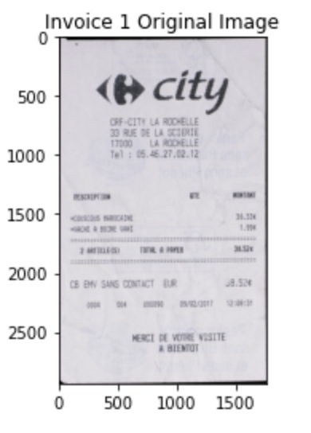

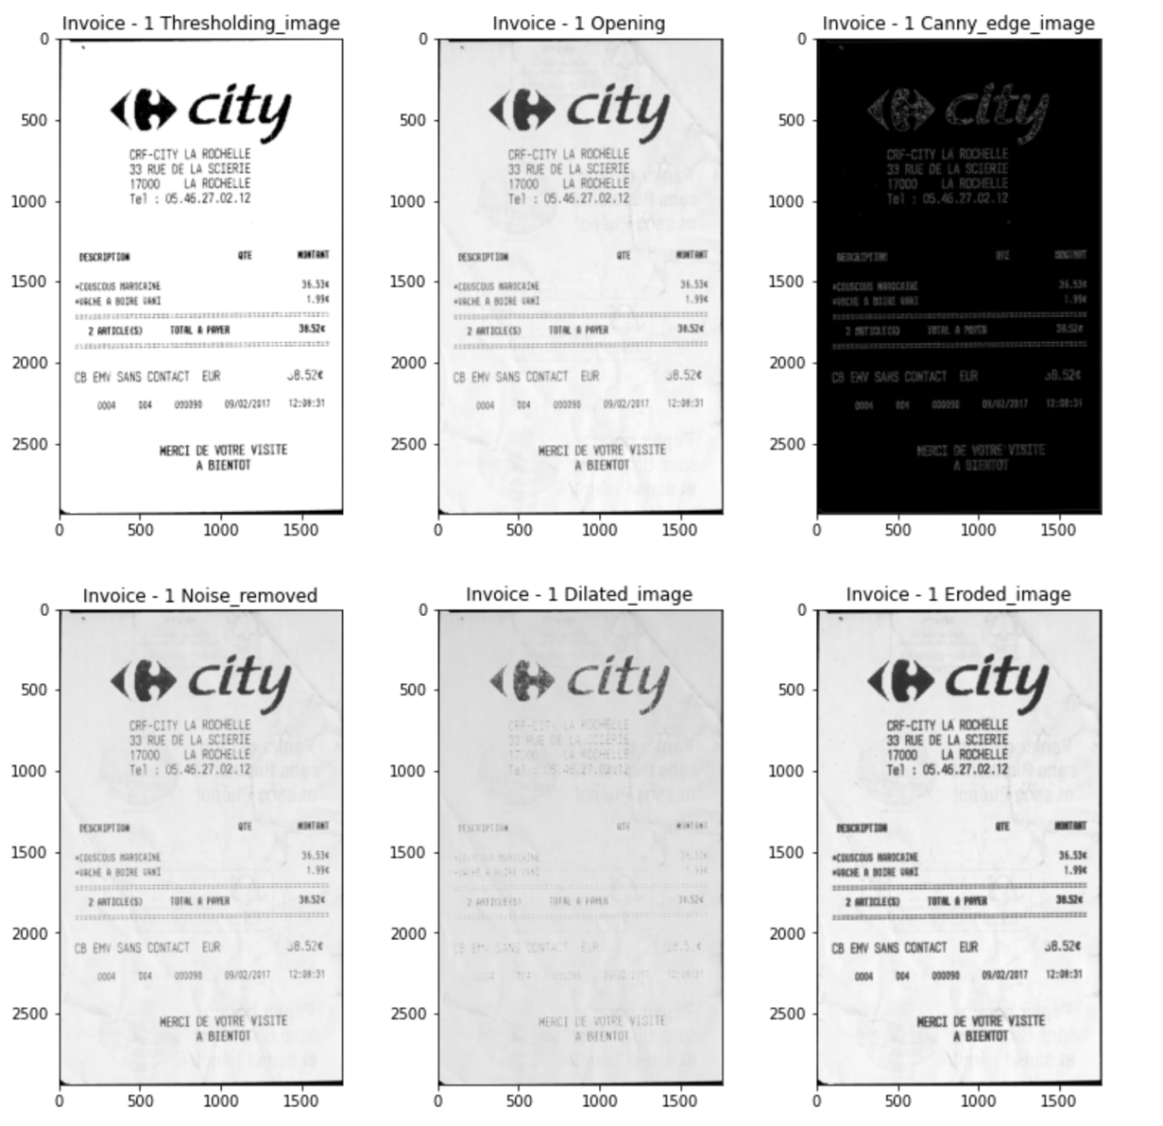

Figure 12 - Invoice Image 1

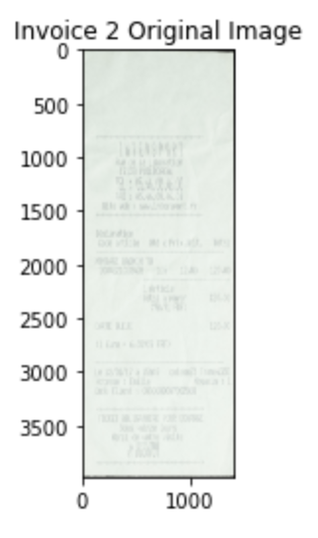

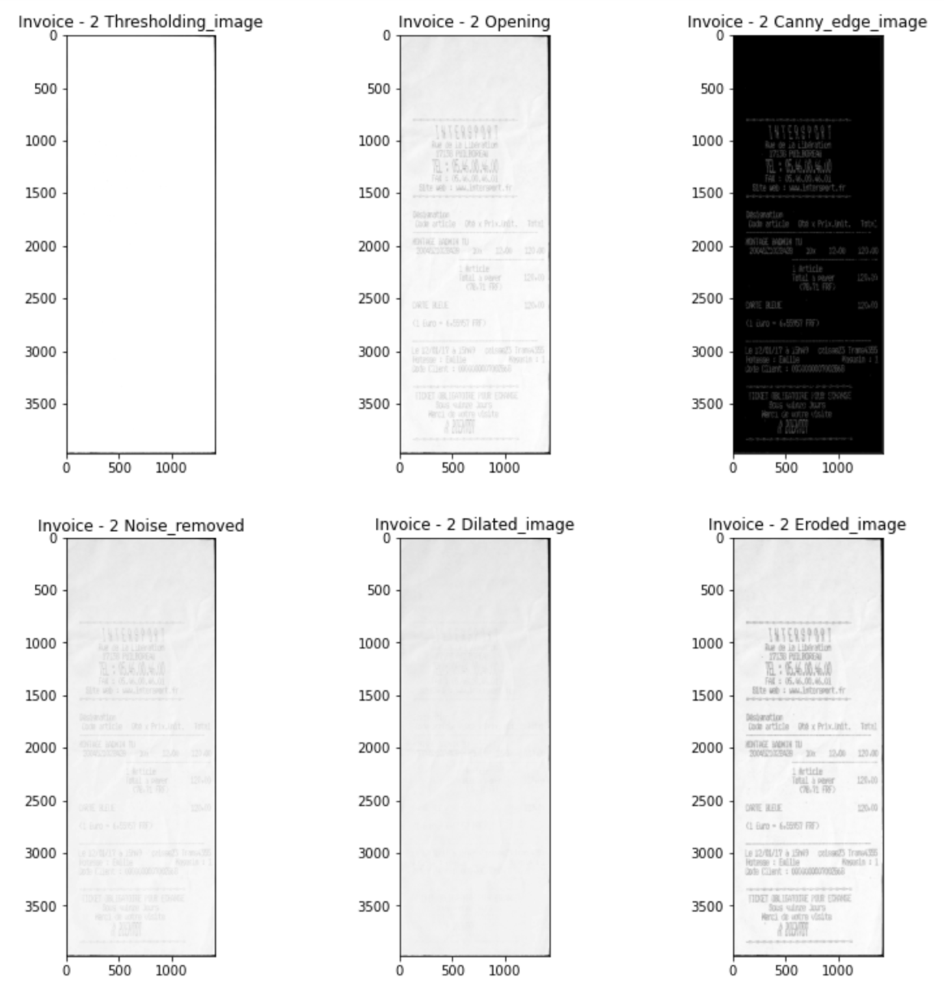

Figure 13 - Invoice Image 2

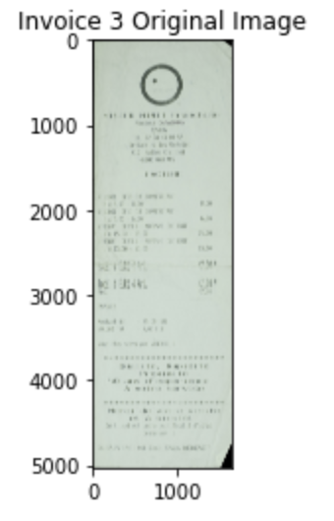

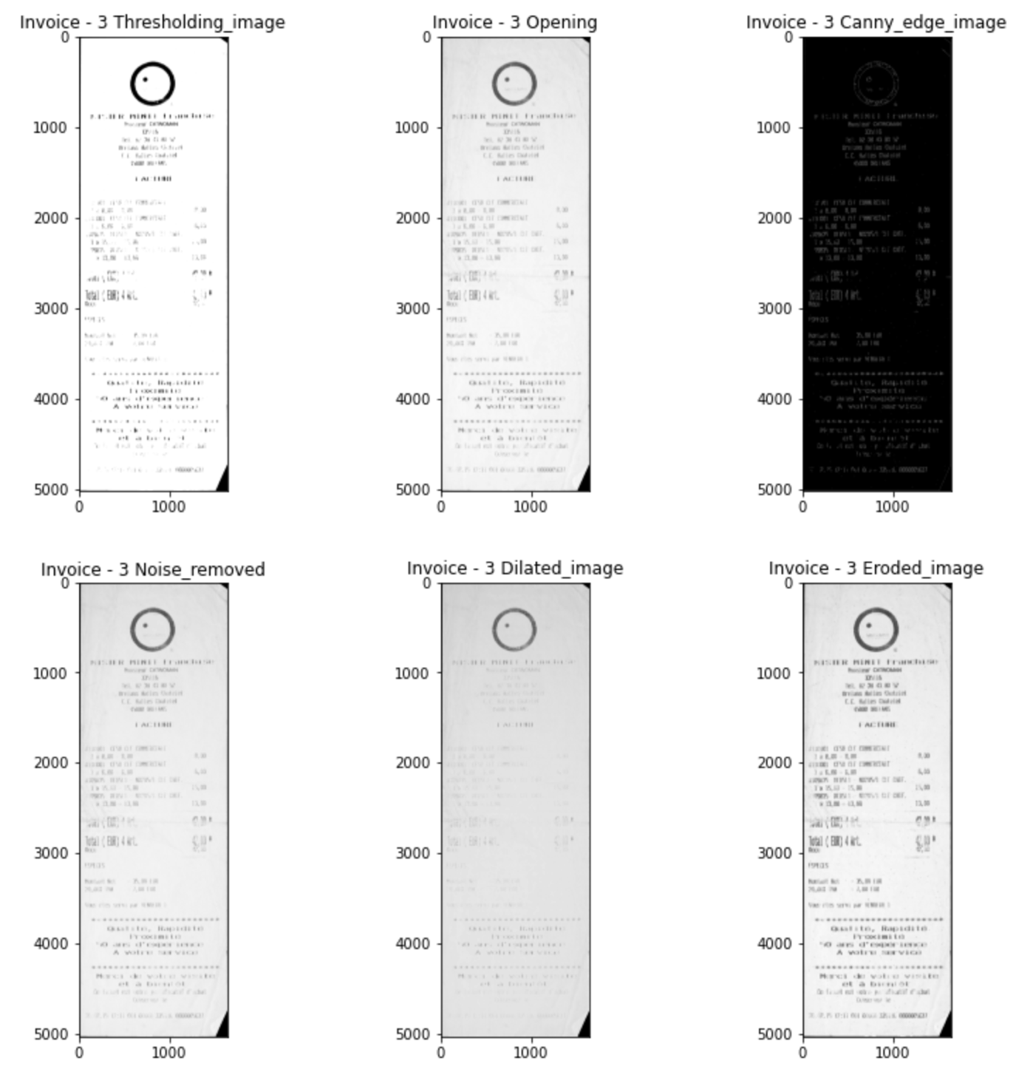

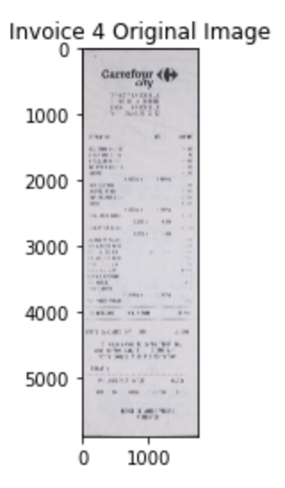

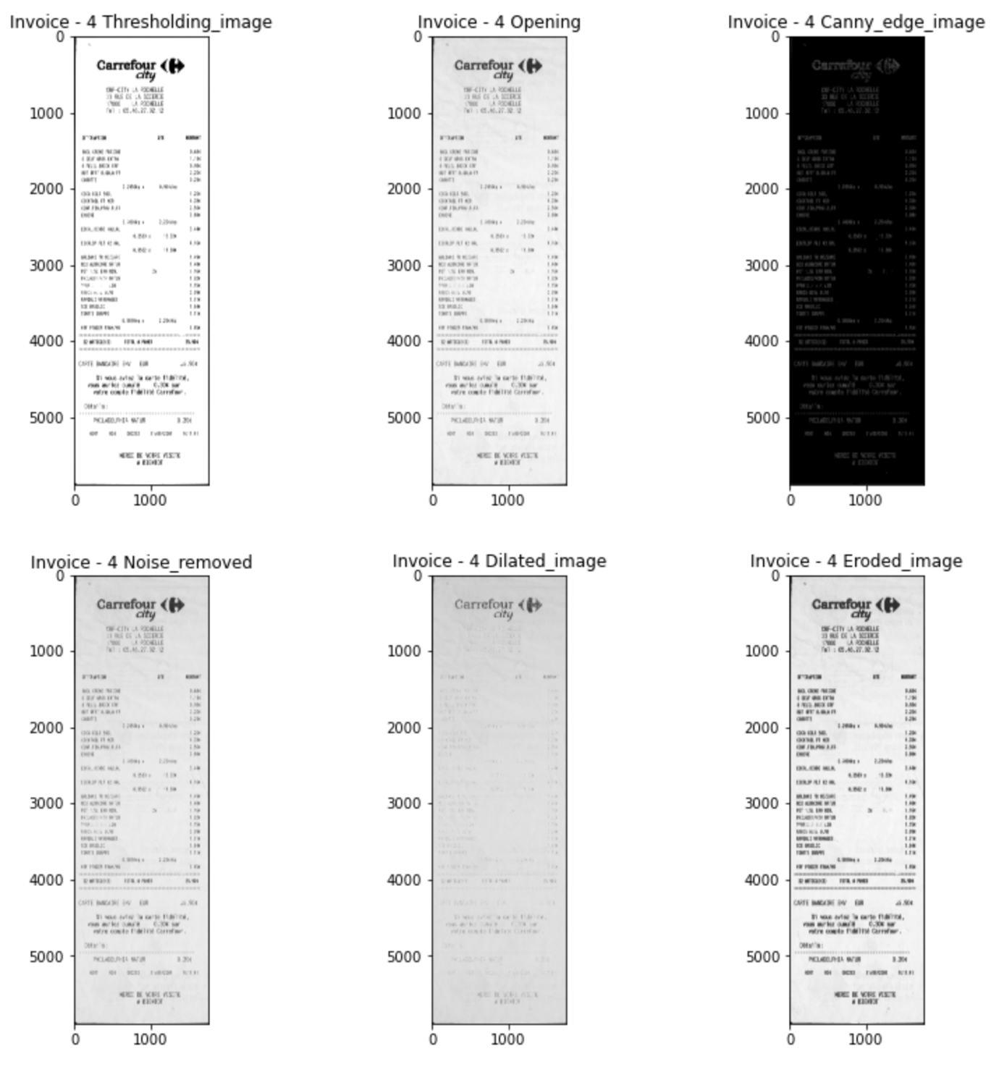

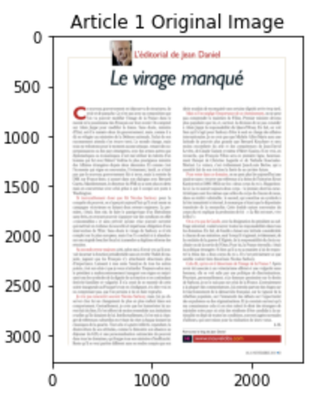

Figure 8 – Article Image 1

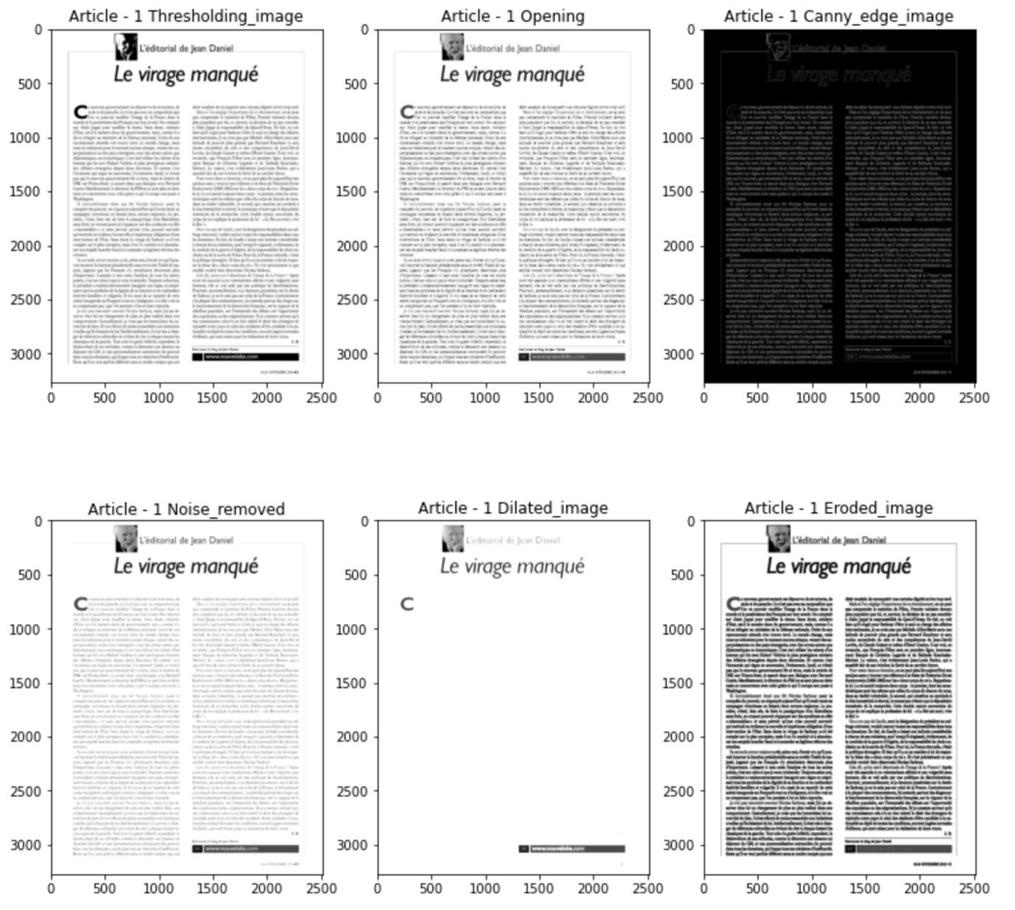

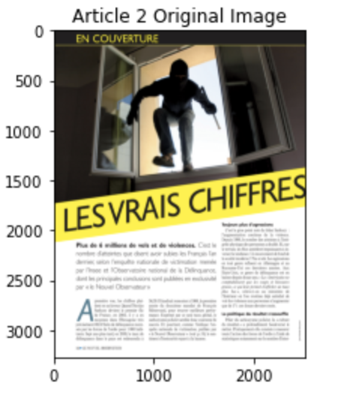

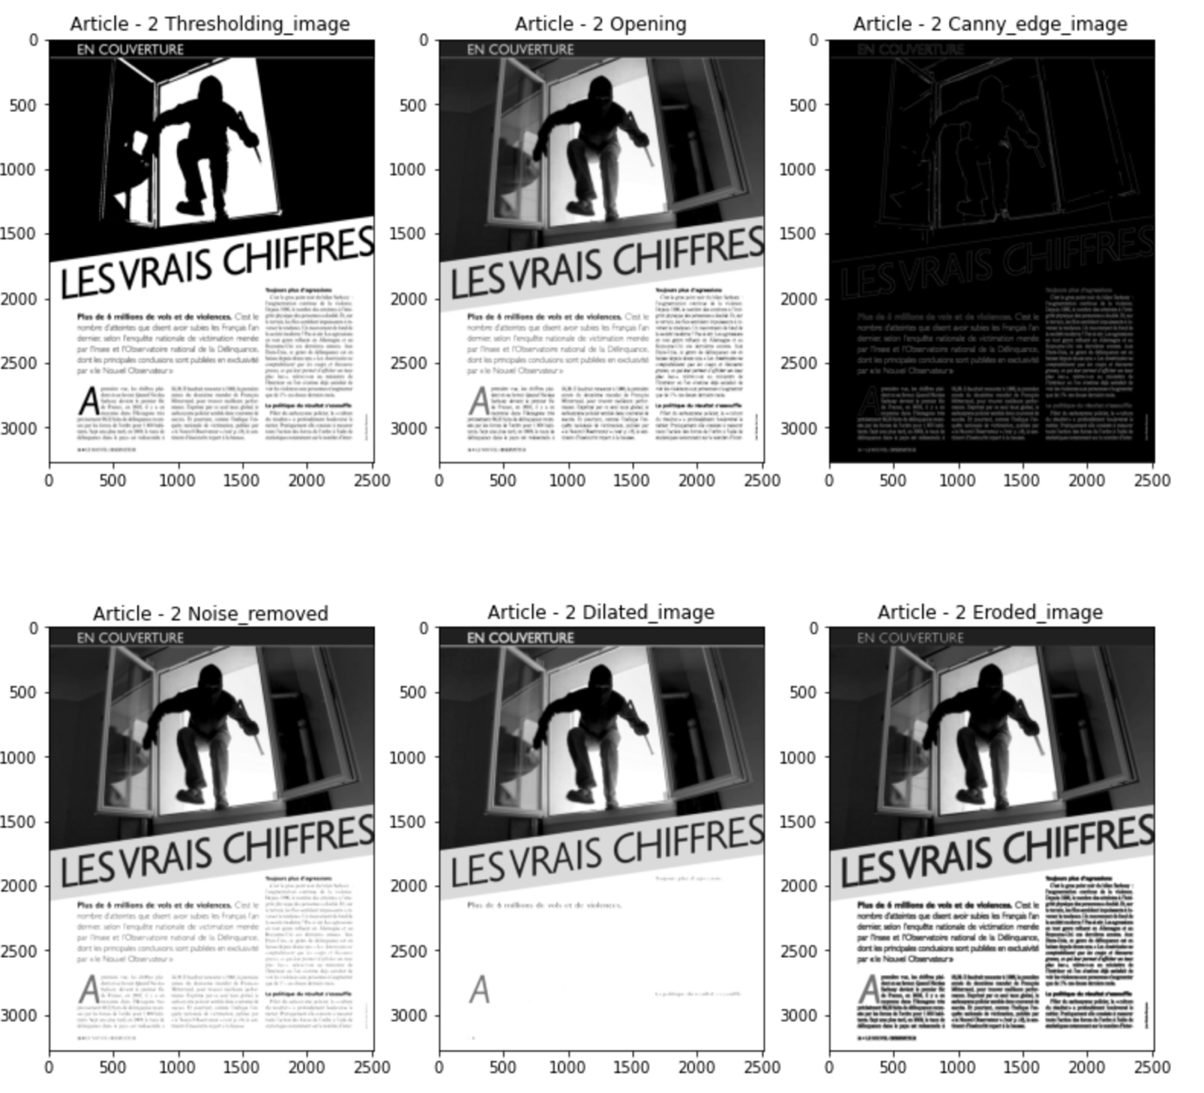

Figure 9 - Article Image 2

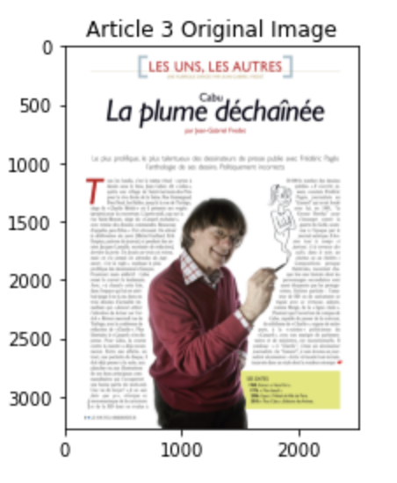

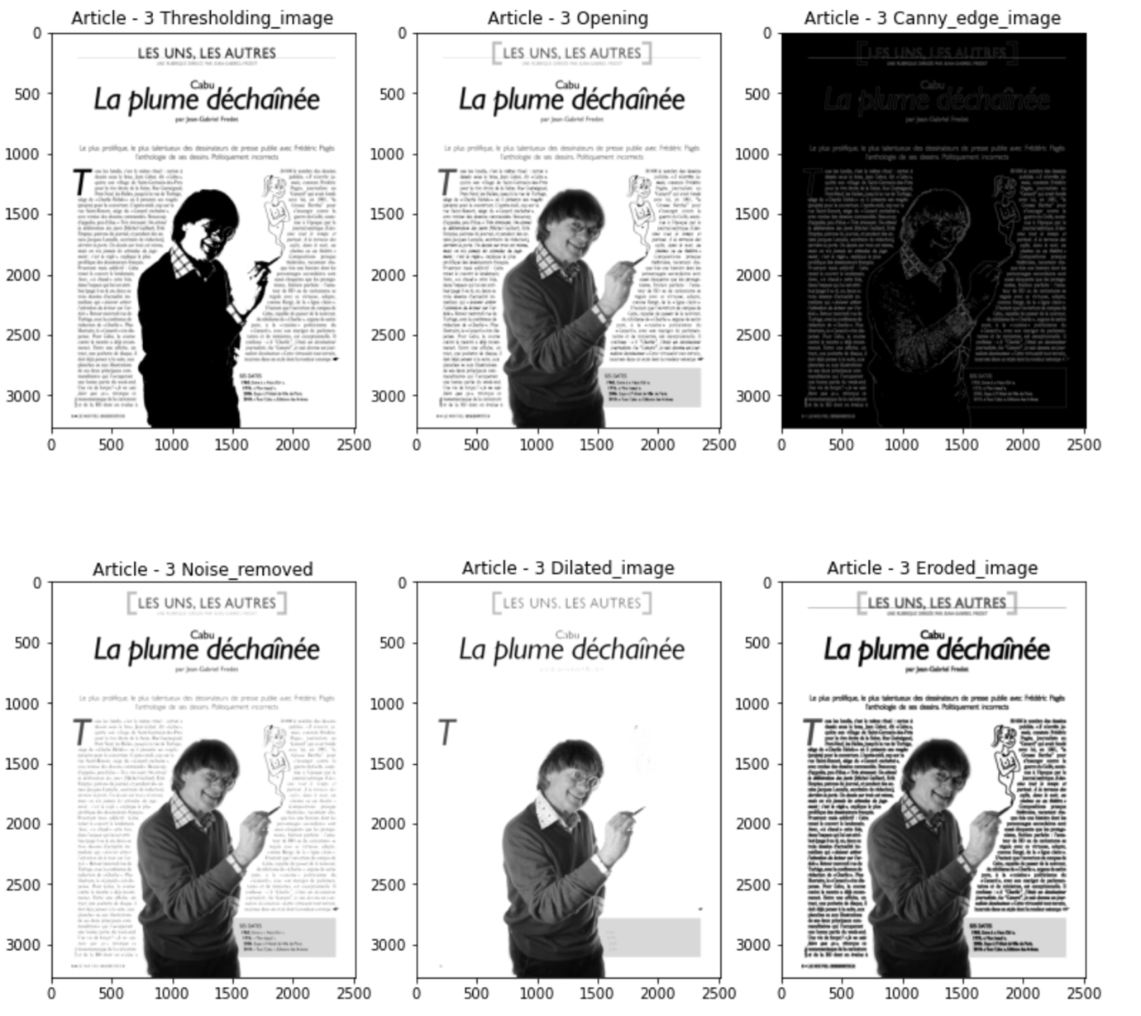

Figure 10 - Article Image 3

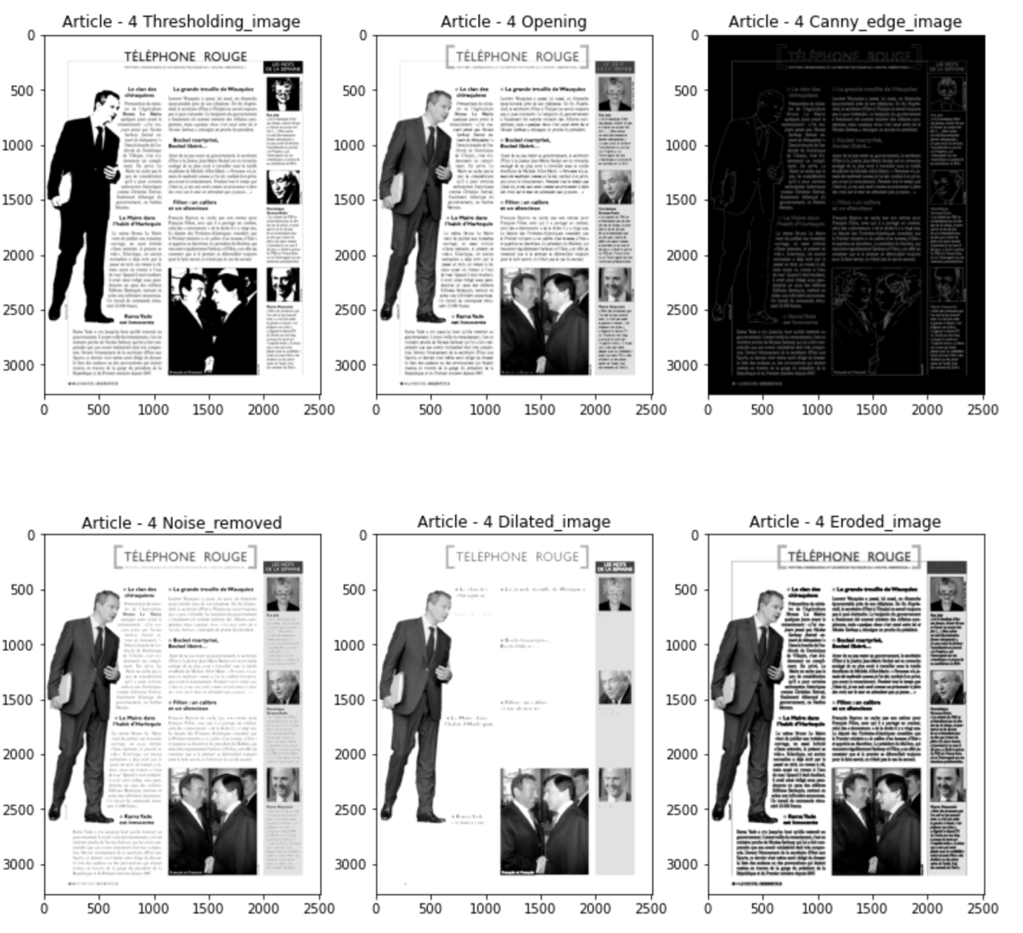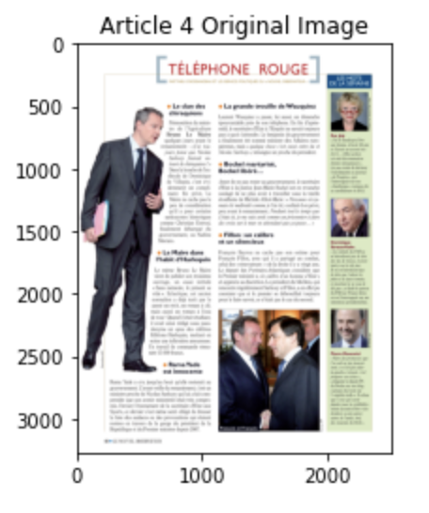

Figure 11 - Article Image 4

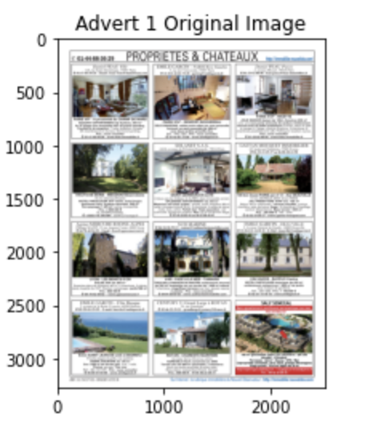

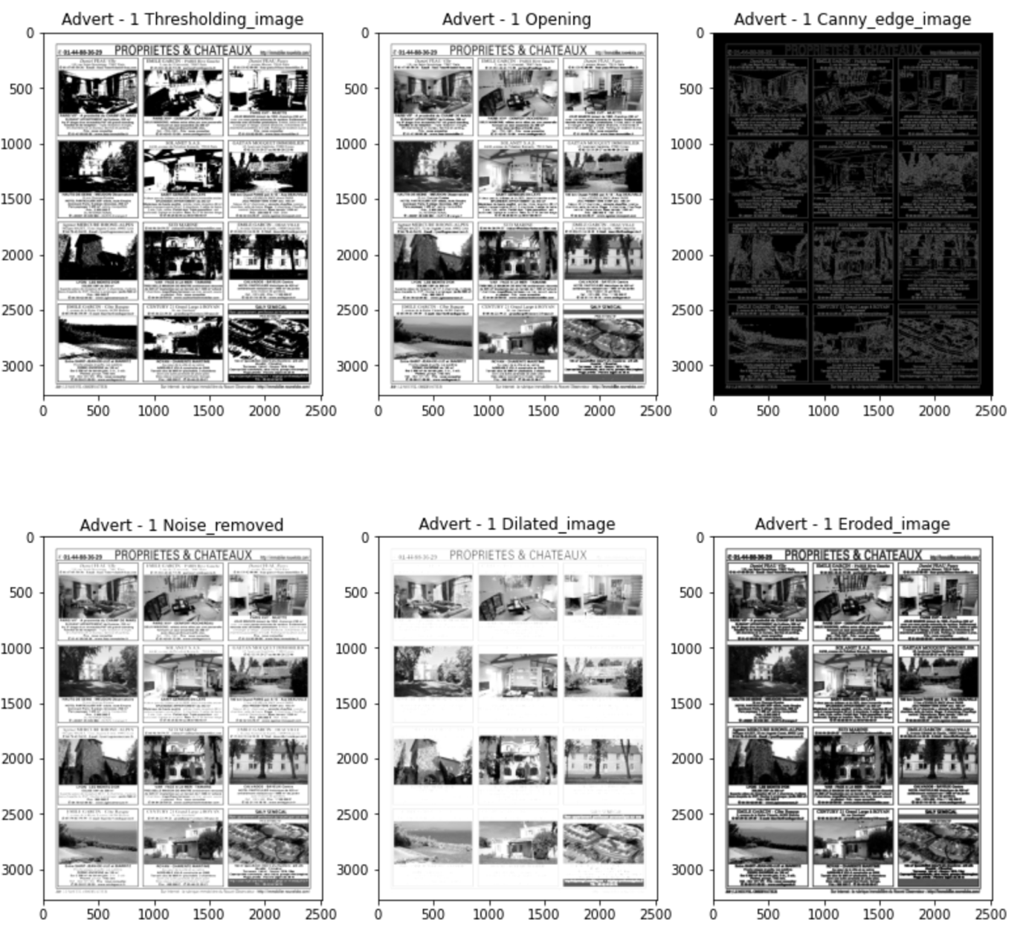

Figure 12 - Advertisement Image 1

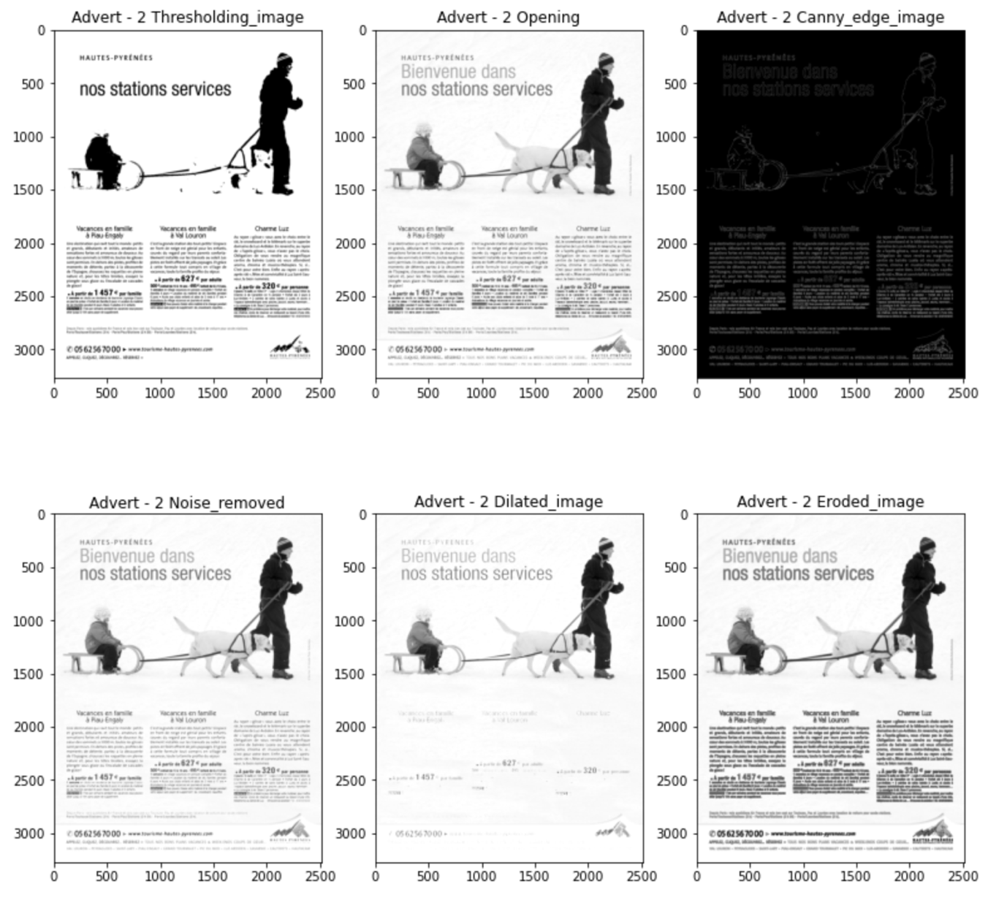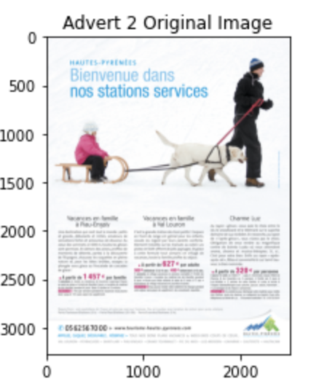

Figure 13 - Advertisement Image 2

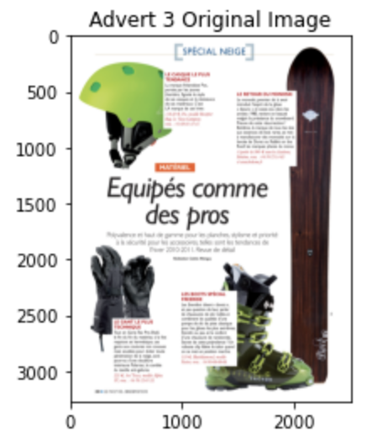

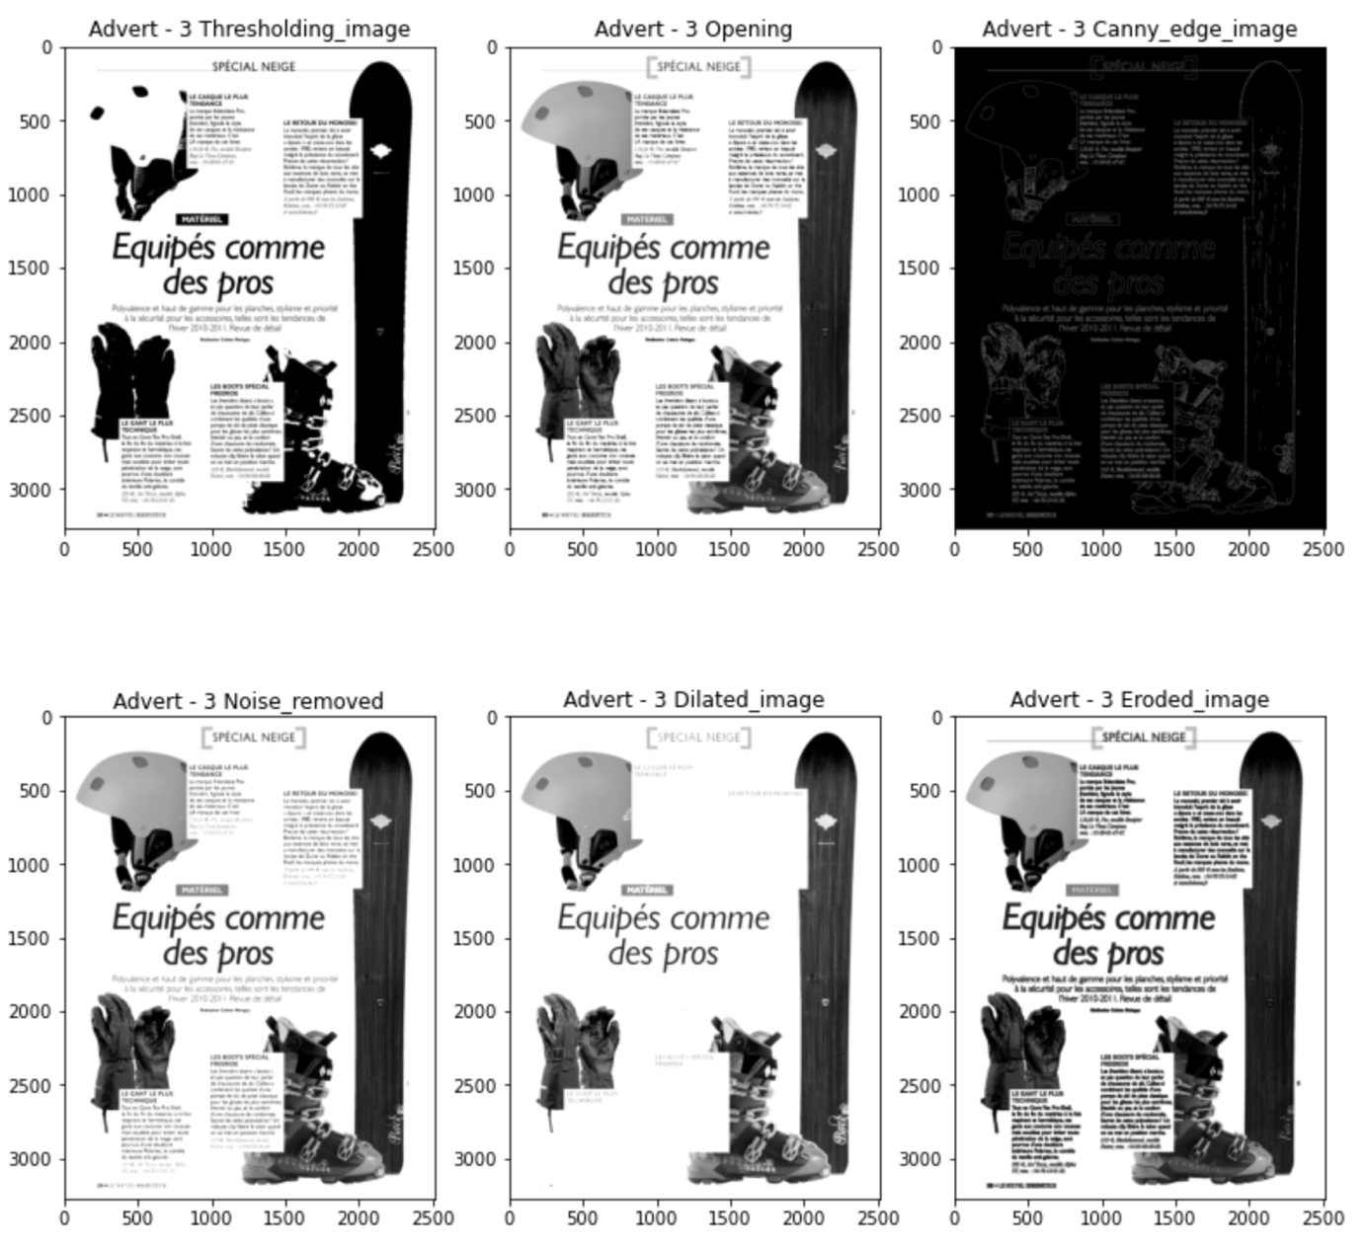

Figure 14 - Advertisement Image 3

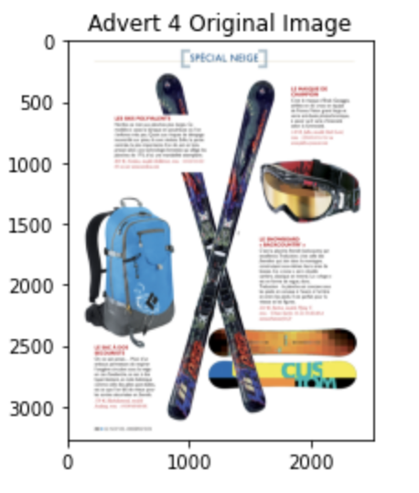

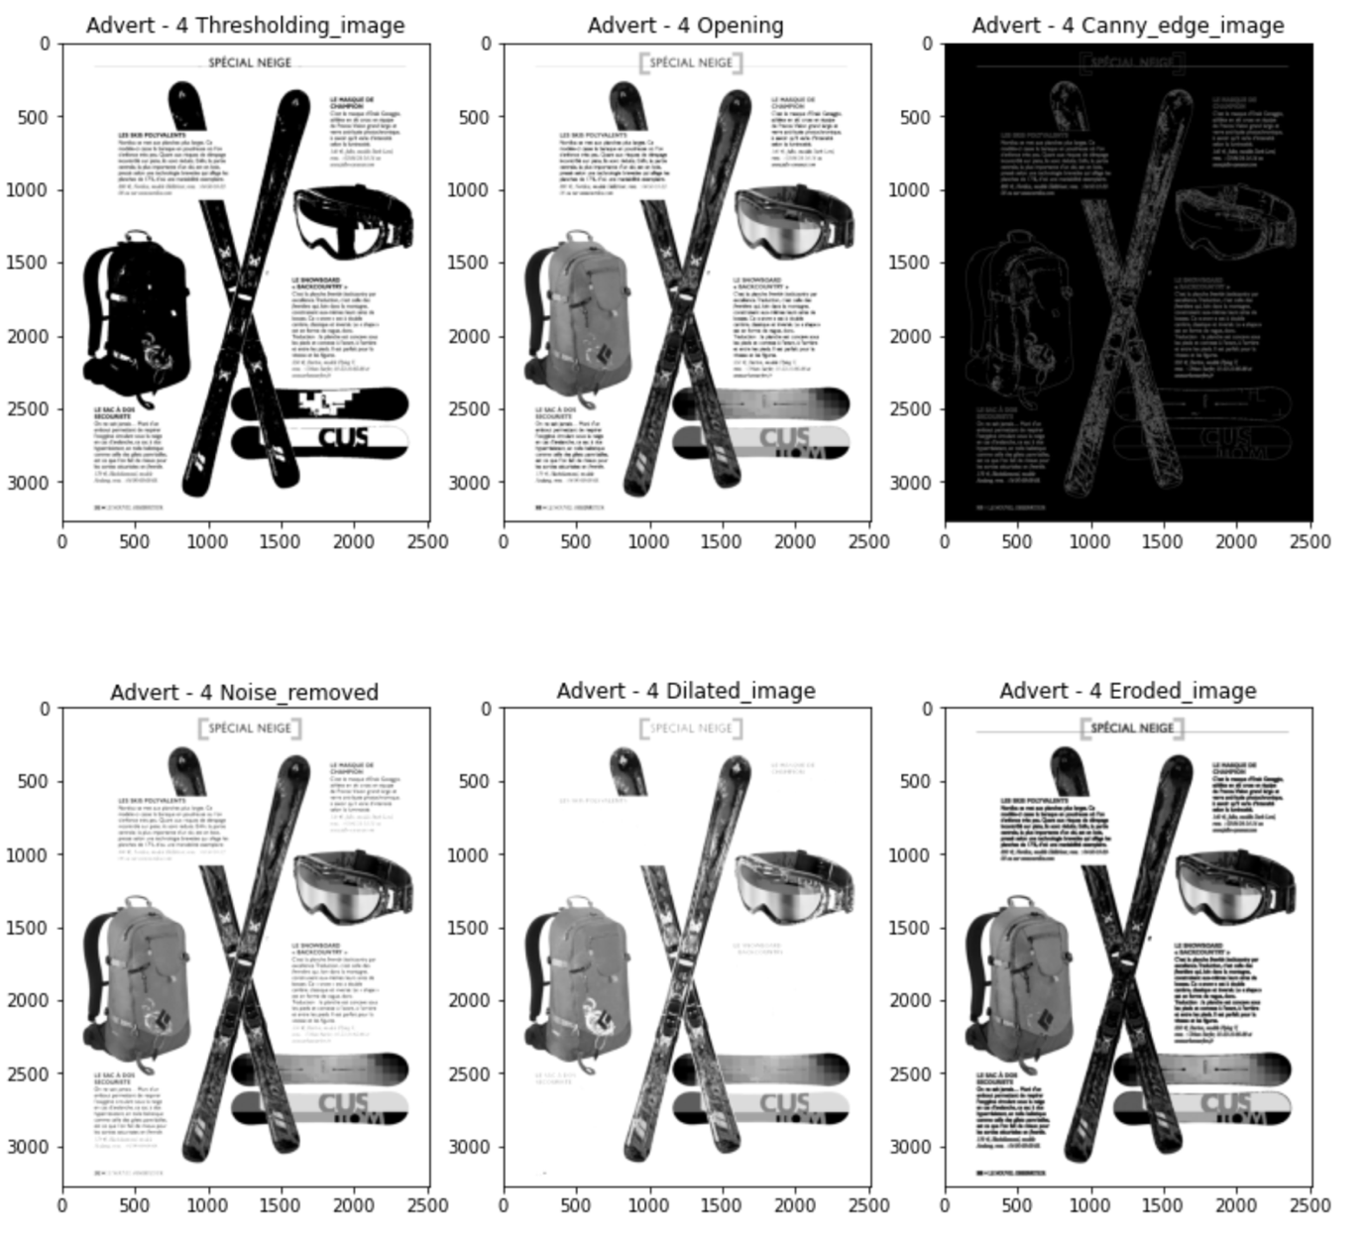

Figure 15 - Advertisement Image 4